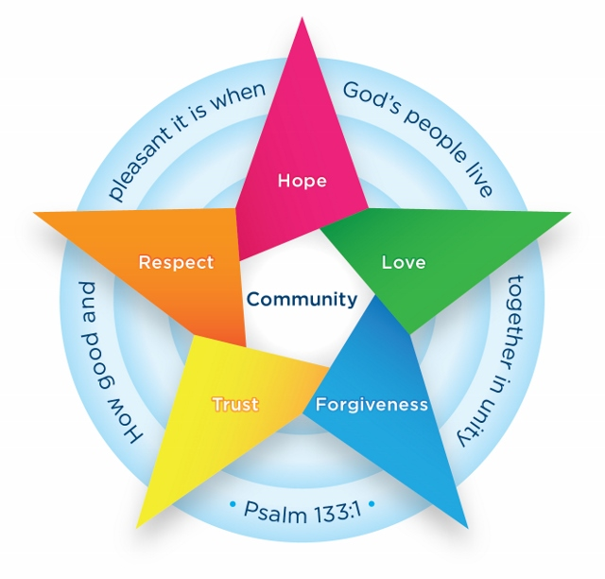

Batley Parish CE Primary Academy

PSHE Policy

June 2025

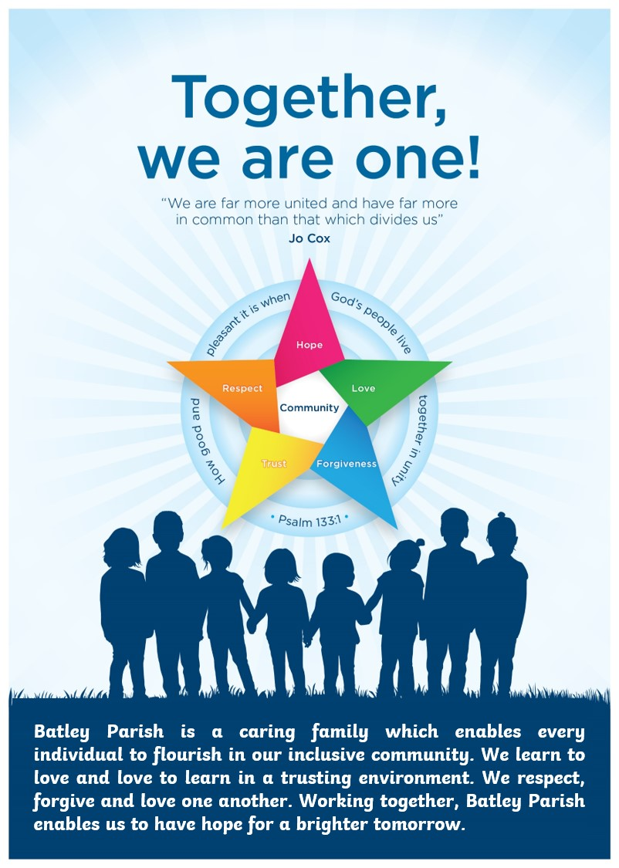
ontents
1. Aims 3
2. Statutory requirements 3
3. Content and delivery 3
4. Roles and responsibilities 4
5. Monitoring arrangements 4
6. Links with other policies 5

1. Aims
At Batley Parish CE Primary Academy, we believe every child deserves the chance to grow into a confident, caring, and resilient individual. Our PSHE (Personal, Social, Health and Economic education) and RSE (Relationships and Sex Education) curriculum is at the heart of this journey, offering children the essential knowledge and skills they need to navigate life’s challenges with confidence and kindness.
We aim to:
- Provide a safe and supportive space to explore emotions, identity, relationships and the wider world.
- Teach key life skills such as resilience, empathy, critical thinking and communication.
- Promote physical and emotional wellbeing, personal safety and online safety.
- Teach about the Protected Characteristics (e.g. race, religion, disability, gender and family structure) to promote fairness and respect.
- Embed British Values such as democracy, rule of law, individual liberty and respect for others.
- Ensure all pupils, including those with SEND, can fully access the curriculum.

Our PSHE and RSE offer supports every child’s personal development and prepares them for life in modern Britain.

2. Statutory requirements
PSHE is a non-statutory subject. However, there are aspects of it we are required to teach.
- We must teach relationships education under the Children and Social Work Act 2017, in line with the terms set out in statutory guidance
- We must teach health education under the same statutory guidance.

3. Content and delivery
3.1 What we teach
As stated above, we are required to cover the content for relationships and sex education, and health education, as set out in the statutory guidance (linked to above).
Refer to our relationships and sex education policy for details about what we teach, and how we decide on what to teach, in this subject. This can be found on the policies page on our website.
For other aspects of PSHE, including health education, see the long term plan on our school website for more details about what we teach in each year group.

3.2 How we teach it
At Batley Parish CE J&I School, PSHE is taught as a discrete subject every week in all year groups, from Nursery to Year 6. Lessons last between 45 and 60 minutes and follow a set of progressive, spiral units that build on pupils’ knowledge and understanding as they move through the school. In addition to these weekly lessons, key aspects of the PSHE curriculum are reinforced throughout the wider school offer, including during daily collective worship, themed weekly assemblies, tutor time discussions, and whole-school events such as Anti-Bullying Week, Children’s Mental Health Week and charity days. Cross-curricular links also strengthen understanding, with PSHE themes appearing in subjects like science (e.g. health), computing (e.g. online safety), and PE (e.g. teamwork and wellbeing).

Associated visits
Learning is further enriched by a range of school trips and workshops linked to PSHE themes. Examples include visits from local emergency services, and workshops delivered by the NSPCC and other specialist organisations. The curriculum is primarily delivered by class teachers, who follow our whole-school programme of study supported by carefully chosen resources. Certain sessions are enhanced by external agencies, such as healthcare professionals, community police officers, or trained charity speakers, where appropriate.

Special Educational Needs and Disabilities
We are committed to ensuring all pupils can access and engage with PSHE, including those with special educational needs and disabilities (SEND). Lessons are fully inclusive, using adapted materials, differentiated activities, visual aids, pre-teaching of vocabulary, and targeted adult support where necessary. The curriculum is designed to reflect and respect the diversity of all pupils, including different cultural backgrounds, family structures and protected characteristics.

Sensitive topics
Teachers approach controversial topics and difficult questions with sensitivity and professionalism. Ground rules are established at the start of each unit to create a safe, respectful environment for discussion. Anonymous question boxes may be used to help pupils ask questions they might find difficult. Staff ensure lessons are balanced and factual, and they are trained not to let their own personal beliefs or values influence teaching. If a teacher has concerns about their ability to deliver a particular topic, they are encouraged to speak to the PSHE subject lead or a member of the senior leadership team. Additional training, support or team teaching can be arranged to ensure all staff feel confident and well-prepared.

Assessment and teaching methods
We use a wide range of teaching methods and resources, including storybooks, circle time, role play, case studies, video clips, pupil-led discussions and creative tasks such as posters for their floor books. Our main planning follows the PSHE Association’s Programme Builder, supported by Jigsaw and SCARF where appropriate. Assessment takes place through a combination of baseline tasks, pupil self-reflections, teacher observations and end-of-unit activities. Progress is tracked using age-appropriate ‘working towards’, ‘expected’ and ‘greater depth’ descriptors, and moderated across year groups for consistency.

Family involvement
Progress in PSHE is reported to parents through annual written reports and discussions during parent evenings. In addition, parents are consulted in advance of any RSE topics considered sensitive, and are invited to review the teaching materials and ask questions. Curriculum information is also shared half-termly via the school website to keep families informed and involved. Through this comprehensive and inclusive approach, we ensure every child receives high-quality PSHE education that prepares them to thrive in modern life.

4. Roles and responsibilities

4.1 The governing board
The governing board will approve the PSHE policy and hold Headteacher to account for its implementation.

4.2 The Headteacher and Senior Leadership Team
The Headteacher and Senior Leadership Team are responsible for ensuring that PSHE is taught consistently across the school.

4.3 Staff
Staff are responsible for:
- Delivering PSHE in a sensitive way
- Modelling positive attitudes to PSHE
- Monitoring progress
- Responding to the needs of individual pupils

4.4 Pupils
Pupils are expected to engage fully in PSHE and, when discussing issues related to PSHE, treat others with respect and sensitivity.

5. Monitoring arrangements
The PSHE subject lead, Mrs Rebecca Aka, monitors teaching and learning regularly to ensure the curriculum is delivered effectively across school. This includes:
- Learning walks – Observations of lessons to see how PSHE is being taught and how pupils are engaging.
- Pupil voice – Talking to pupils about what they’ve learned and how safe and supported they feel in lessons.
- Staff feedback – Teachers are encouraged to share their confidence levels and training needs.
- Annual review – The curriculum is reviewed each year to make sure it remains up to date and meets pupils’ needs.
All monitoring helps improve practice, share what’s working well, and make sure all pupils get a high-quality PSHE education.
This policy will be reviewed by Mrs Rebecca Aka, PSHE Coordinator, biannually. At every review, the policy will be approved by the governing body and Mrs Sennett.

6. Links with other policies
This policy links to the following policies and procedures which can be found on the policy page of our website. The related policies include:
- RSE Policy

