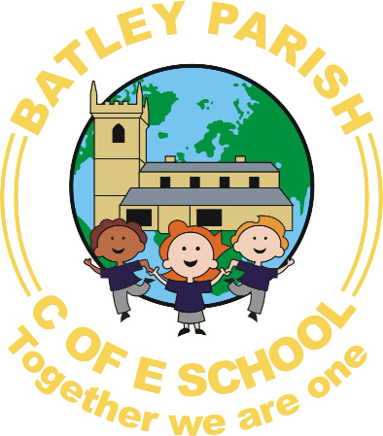

Batley Parish
Early Years Foundation Stage
Reception Class
Welcome Pack 2021
http://www.batleyparishpri.kgfl.dbprimary.com
Twitter- Reception@Batleyparish


We would like to give you and your child a warm welcome to Batley Parish Junior, Infant and Nursery School. We are very much looking forward to sharing your child’s learning journey and delighting in their achievements and successes with you.
We hope that this information answers many of your questions. Please feel free to speak to a member of staff at any time if you have any queries or questions.

Your child is in the Early Years Foundation stage of their education. It is the stage that they are in from birth until they are five years old. We teach your child in accordance with the statutory framework of the Early Years Foundation Stage.
At Batley Parish School, our Foundation Stage consists of a thirty place reception class and a sixty five place nursery which is based on two sites. We are very fortunate that both the Reception class and the Nursery have fantastic indoor and outdoor spaces where children can learn and develop.
The Early Years team is led by Miss Charlotte James who is the Early Years Coordinator and a lead teacher for Kirklees. We have a highly skilled team of Early Years Practitioners who ensure that your child receives the best quality of education.
Miss Charlotte James- Early Years Coordinator/ Reception Teacher
Miss Naadhirah Chothia- Part time Nursery Teacher/ Covers Reception Class on a Wednesday afternoon.
Mrs Meymoona Saloo - Early Years Practitioner / Cover Supervisor
Mrs Amina Daji- Early Years Practitioner/ HLTA Friday PM
To ensure that all of our staff have a deep knowledge and understanding of how young children in the foundation stage learn and develop, we ensure that members of staff spend time within the Reception and the Nursery classes.
There are seven areas within the Early Years Foundation Stage Curriculum. These consist of three prime areas and four specific areas.
Prime Areas of Learning – These are fundamental and essential for children to move forward in the Specific areas of Learning.
Personal, Social and Emotional Development
Communication and Language
Physical Development
Specific areas of Learning- These areas teach essential skills children will need in life.
Literacy- Reading and Writing
Mathematics- Numbers, Shape and Measuring
Understanding of the World- ICT, People and Communities, Science
Art and Design- Music, Art, Dance and Role play
At Batley Parish Junior, Infant and Nursery School we very much believe that children learn through play and to ensure this we organise both the Nursery and the Reception into areas of provision. These areas consist of;
- Sand play
- Water play
- Investigation areas
- Mark making/Writing area
- Mathematics games and activities
- Small/Large Construction
- Role play e.g. Home corner, Vets, Shops, Doctors
- Paint and Art area
- Malleable area e.g. Play dough or Clay
- ICT area- computers, SMARTboard, iPads, remote control toys
- Book and Phonics area
- Collage Area
- Snack/ Café area-
- Design and Technology work shop
- Physical play e.g. climbing areas, tricycles, bikes, bats and balls
Areas of provision are then enhanced on a regular basis dependent upon your child’s needs or interests. For example if the children are learning about growing and change we may plan to enhance the home corner to a baby clinic. If children show an interest in dinosaurs, we will enhance the sand tray with dinosaurs and plants,
Children can move freely between the indoor and the outdoor area and can access all of these areas of provision. Some children naturally prefer to learn in the outdoors and therefore we ensure that children have opportunities both indoors and outdoors
Children are encouraged to find out and explore, be willing to have a go, keep trying, have their own ideas and choose ways to do things. These are called the Characteristics to effective learning. Children are then supported by adults who interact and observe their play. All adults in the setting contribute to weekly staff meetings and are aware of your individual child’s next steps.
Practitioners teach children by ensuring challenging, playful opportunities across the prime and specific areas of learning and development. Play is an essential part of their learning and development and we ensure that the environment enables and supports their play.

‘Children are born ready, able and eager to learn. They actively reach out to interact with other people, and in the world around them. Development is not an automatic process, however. It depends on each unique child having opportunities to interact in positive relationships and enabling environments.’ EYFS (2012)
All Early Years Practitioners have their own iPad and carry out spontaneous observations of your child. These consist of written, photographic and video evidence. We then upload these observations onto an electronic assessment tool called ‘Early Years Essence.’ You will be given your own personal log in so that you can read these observations at home and make comments about them. We then track your child’s progress against the curriculum and plan their next steps. You can also upload your own photographs and observations at home which can contribute to your child’s learning journey. Children will also receive a half termly homework grid in the Reception class that supports their learning and development at home. This enables you to choose which activities you complete with your child at home.
What should my child wear to Reception?

Children will be actively encouraged to learn indoors and outdoors and will need appropriate clothing at different times of year. Please can you provide the following?
- A pair of wellington boots
- A warm, waterproof coat
- Waterproof Trousers
- PE kit which is in a named cotton pump bag, we suggest wearing
white t-shirt and black / blue shorts
Children are taught to be independent and therefore need to practice putting dressing and undressing at home; this includes fastening laces and buttons on clothing.
Please make sure that your child’s name is written clearly on all of their clothing and footwear.
Absence Procedure
It is compulsory for your child to attend school every day. The school day begins at 8.55am and children need to arrive promptly. In the event of illness you must contact the main school office by 9:30am at the latest. You can contact us on the school office on 01924 326361
Sometimes children feel unwell when they wake up but after a spoonful of Calpol or similar, they will quickly feel well enough to come into school. Please endeavour to bring your child in and we will keep an eye on them over the day.
Mrs Tracy Bairstow is our current Family Liaison/Attendance Officer and will contact you by telephone before 10:00am if you have not informed us of your child’s absence. If there is no reply, Mrs Bairstow may visit your home address to find out why your child isn’t at school.
If your child has a Doctors or a Dental appointment, then please provide a copy of their appointment card.
Holidays should not be taken during school term time unless these are exceptional circumstances and will be approved by the Head teacher. These are as follows;
- A family member is seriously ill.
- There has been a death or significant trauma in the family and a holiday may help the child to cope better
- Parent/carer inflexible leave allocation e.g. fixed term holidays
Home-time Procedure
We have a strict home time procedure that is designed to keep your child safe. We ask that if you are running late that you contact the school so that we can reassure your child.
If you cannot collect your child, you must inform a member of staff and inform us of who will be collecting your child instead. We will not let your child go home with a relative or friend if we have not met them before or if we haven’t been informed. This can often cause a lot of distress to the relative or friend collecting and the child who is waiting to go home. Therefore we ask that you inform us when your child arrives so that we can allow your child to go home safely.
Does my child take part in collective worship?
At Batley Parish C of E School your child will be part of a daily collective worship which are themed on a weekly basis. As a Church School, it is very important that children learn respect and understanding of different faiths and beliefs and because of this we teach children about different cultural celebrations and religions. We also have a family service which is currently every Monday afternoon which is often led by Father Martin or a representative from the Church. We also celebrate Christian festivals such as Harvest, Christmas and Easter by attending special Church services where you are invited to join us.

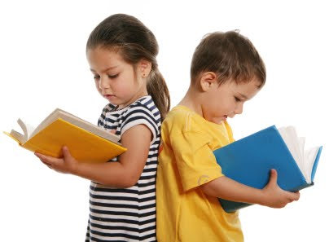
School Library
We actively encourage that you join Batley Library and encourage and foster children’s interest in books. Listening to and joining in with stories is an essential part of developing children’s listening and reading skills. Children can find out about the world around them through books.
We also have our own school library with a selection of story and information books. These books will be changed every Friday.
Homework
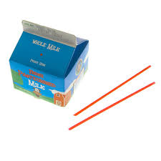
We encourage that your support and extend your child’s learning and development at home by sharing home work on a weekly basis. This is often very practical and is aimed to be fun.
When your child is ready, they will also receive a reading book and a set of spellings on a weekly basis. Your child will have a spelling test every week and receive a new set of spellings to practice at home.
Daily Snack/Lunch
Milk is provided at no cost until the term before your child is five years old.
Milk is then charged at a cost of £11.65 per term.
Milk is provided in cartons with a straw and we will provide a name label on each carton so that your child can select their own milk.
We also have a self-service snack area in both of our Nursery and Reception classrooms where children can have fresh fruit, cereals, toast and even make a healthy afternoon snack. We use your snack money donations to fund this.
You do not pay for fruit as this is provided free of charge from the Government, however we ask for a voluntary contribution every Monday that helps us buy breakfast. We also use this money to pay for extra resources such as baking ingredients, seeds for planting etc.
A full day is 9:00am - 3:00pm (six hours). Children will bring a packed lunch or can order a school dinner. Children are supervised by a lunchtime dinner lady and will eat their dinner in the main school hall.

Tips before my child starts School
- Talk with your child and discuss how they are feeling about starting school. You could make a worry box and write down their feelings to help overcome feelings of anxiety or uncertainty.
- Follow the class page on Twitter and find out what is happening in the Reception class.
- Look at the school’s website and go to the Reception class page to find pictures and videos about school that you and your child can watch together.
- Help your child to be able to write their name independently by copying it from a name card. Please avoid writing their name in capital letters e.g. RIZWAN
- Encourage increasing independence when getting dressed and undressed such as putting on their coat, socks and shoes by themselves. Support them to put their uniform on with growing independence. This is important throughout the school year as it really helps children to be independent during P.E lessons.
- Support your child getting use to bedtime and morning routines towards the end of the summer holidays so that they get use to going to bed early and waking up early ready for school. It is really important that children get lots of sleep as you will notice a difference when they begin school and will become tired at the end of their day.
- Support and prepare your child for eating their lunch at school by encouraging them to try different foods at home. Teach them how to use a knife and fork to eat their lunch with as this is what is expected at school.

We hope that his booklet provides you with all of the answers to your questions that will enable your child has a smooth and successful transition into our Reception Class. We also value the importance of building positive relationships with parents and carers and offer an open door policy where all staff are available, friendly and approachable. You will receive a weekly newsletter and we also have our own Twitter page, which we ask you all to follow. It is a fantastic way of finding out what and how your child has been learning at home.
We also offer regular learning together sessions, where you can come and join your child at school.

If you have any further questions that we have been unable to answer, please feel free to contact the school office (01924) 326361 or contact Miss James on the email below;
Charlotte.James@kirkleeseducation.uk

