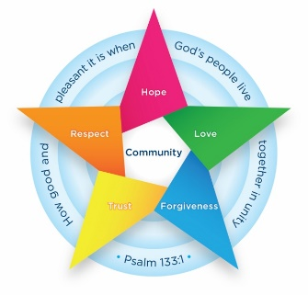
Class 6 Newsletter
Spring term 1 2025
Welcome back, we hope everyone has had a restful break and holiday as we prepare for another very busy half term with intervention sessions continuing and our residential trip!

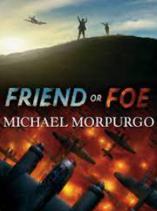
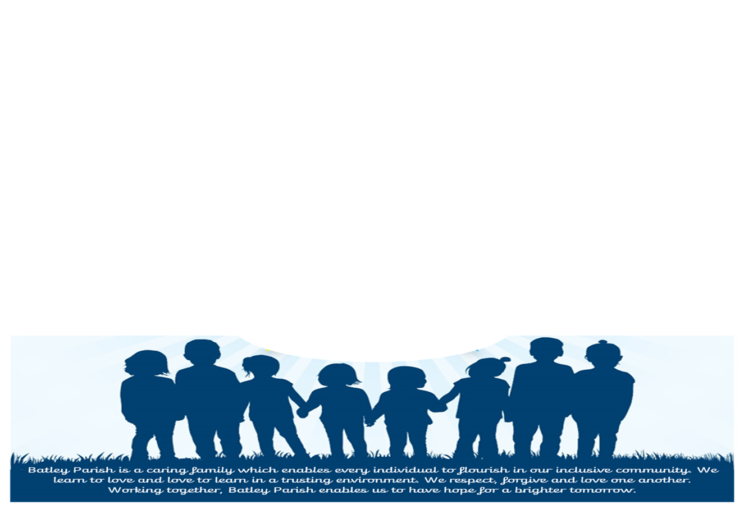
Design and Technology
Our focus this half term will be drawing: Playgrounds, will be concentrating on what skills are required to design and make different structures, testing their stability and comparing different techniques and materials.

RE
In our Religious Education lessons we will be concentrating on what is means for a Muslim to follow God.
Class Information
- Class Teachers - Mr Smith and Mrs Jarzyna. Mr Smith will teach all day Mondays and Tuesdays with Mrs Jarzyna Wednesday-Friday.
- Teaching Assistants – Mrs Iqbal, who will support some intervention groups too.
- PE – PE is on Tuesdays and Fridays. Please come dressed in PE kit.
- Brass Lesson – this year the children will have a brass lesson each Wednesday with a music specialist.
- Reading – Children will be able to take a reading book home. Please listen to your child read and ask them questions about the text. Use this opportunity to investigate new vocabulary.
- Collective Worship – Our collective worship focus is Love.
- Residential dates: January 29th-31st 2025. If you have any further questions please ask. You can use the @6Batley X account to check pictures during our stay at Marrick Priory.

How can parents help at home?
Reading at least three times a week recording in their Reading Record.
Developing arithmetic skills by researching past SATs arithmetic papers, accessing ‘TT Rockstars’ or challenging your child to complete ‘Maths Bot’ arithmetic tests under timed conditions.
History

Our focus this half term is ‘What was the impact of World War II on the people of Britain?’ identifying the reasons for the start of the war, recognising the impact of war and the researching the Battle of Britain. We will also be examining sources about the Blitz and checking the reliability of of sources. Finally, we will be continuing our understanding of evacuation and the role of women during the war.

English
This half term, we will continue to study the book ‘Friend or Foe’ to write a setting description before writing a retell of a particular event in the book using speech. We will also be using our Residential trip to stimulate a setting description.

Maths
In Maths we will be learning about Algebra and Decimals. We will be using ‘Maths Bot’ most mornings to develop the children’s fluency understanding and this, along with ‘Learning By Questions’, will be used to further arithmetic knowledge. Finally, we will finish the half term by revisiting fractions before learning about percentages and decimals.

