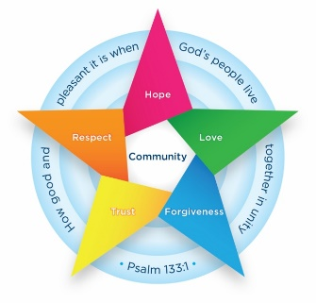
Class 6 Newsletter
Spring term 2 2025
Welcome back, we hope everyone has had a restful break and holiday as we prepare for another very busy term as we build up towards our SATs examinations.

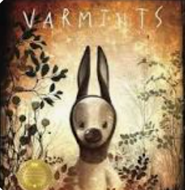

PE
In our PE lessons we will be continuing to develop our swimming skills and completing Tag Rugby sessions.
Art and Design
Our focus this half term we will be completing a painting and mixed media unit. The children will be analysing and discussing different ways in which this can be done; how artists use art to tell stories and examining different types of art.

Geography

Following the completion of our World War Two History topic the children will be investigating a Geography topic: Where does our energy come from?
We will be identifying the significance of energy and the Prime Meridian, investigating different energy sources and using our map skills to locate different energy sources.

Class Information
- Class Teachers - Mr Smith and Mrs Jarzyna.
- Teaching Assistants – Mrs Iqbal
- PE – Swimming will continue to be on a Tuesday. Therefore, please continue to come to school in school uniform brining a swimming bag with swimming costume, plastic bag, swimming cap and a towel. Friday is a day in which we have PE so children are allowed to come to school in their PE kit.
- Spanish – with Mrs Jarzyna is each Friday
- Reading – Children will be able to take a reading book home. Please listen to your child read and ask them questions about the text.
- Collective Worship – Our collective worship focus is Forgiveness
- We will be sharing your child’s latest SATs results and areas to improve later in the term during parents evening as we prepare for our SATs examinations during the week of May 12th-May 15th 2025.

How can parents help at home?
Reading at least three times a week recording in their Reading Record.
Developing arithmetic skills by researching past SATs arithmetic papers, accessing ‘TT Rockstars’ or challenging your child to complete ‘Maths Bot’ arithmetic tests under timed conditions.
English
This half term, we will continue our World War Two context through the Literacy Shed video ‘Behind Enemy Lines’ before switching to the book and video of Varmints in which we will be writing a recount from a different perspective.

Maths
In Maths we will be continuing our work on fractions, decimals and percentages. We will then switch our attention to area, volume and perimeter. Statistics will be the last area of our half termly focus. Throughout the half term we will also use opportunities to recap previously taught skills and continue to develop our fluency skills ahead of the SATs examinations in May.

