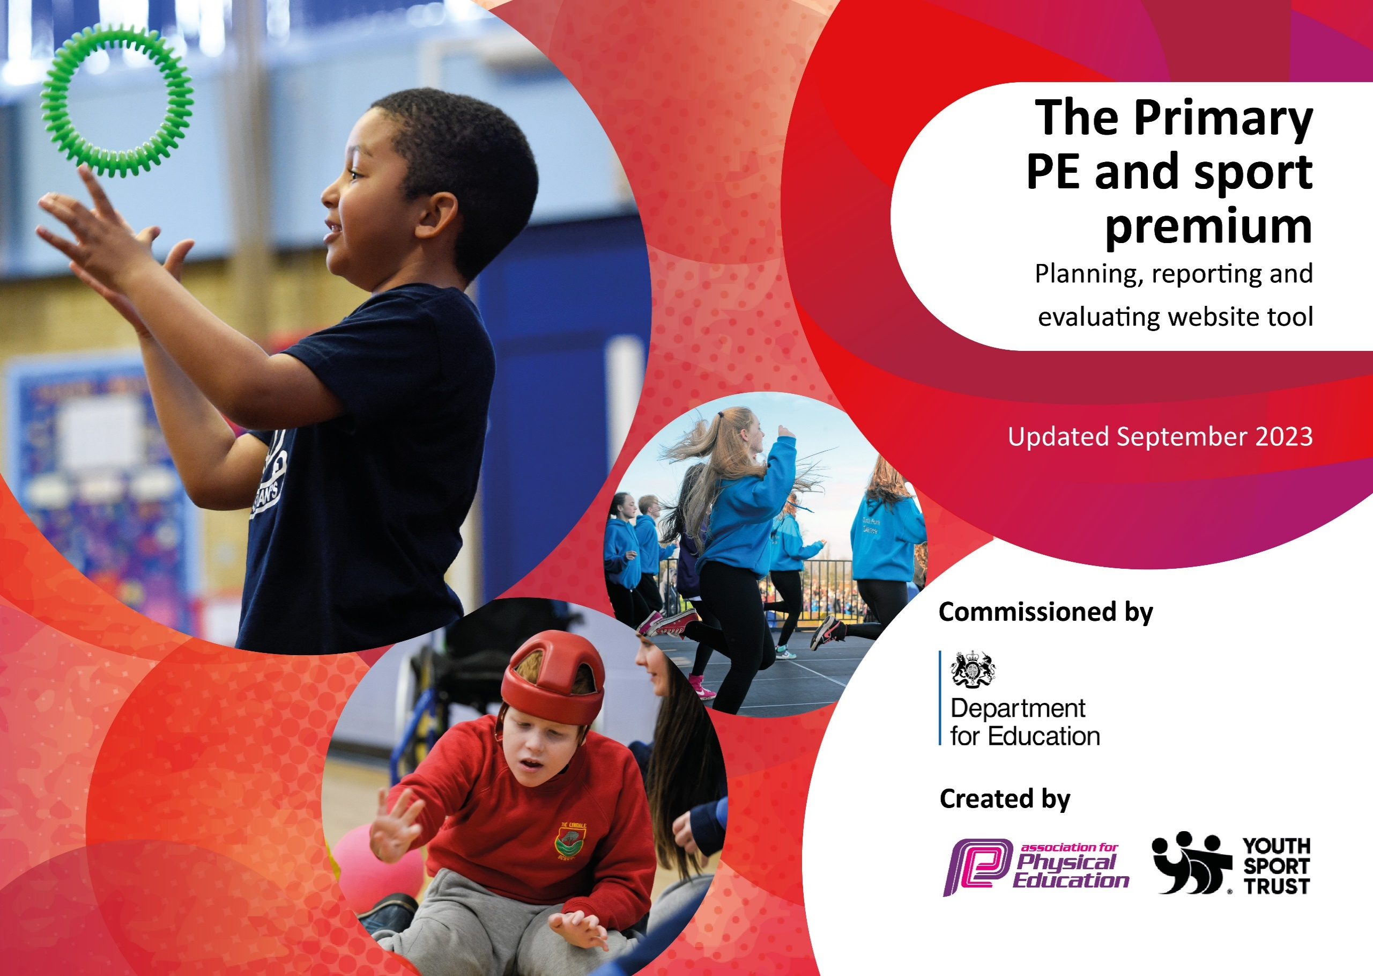

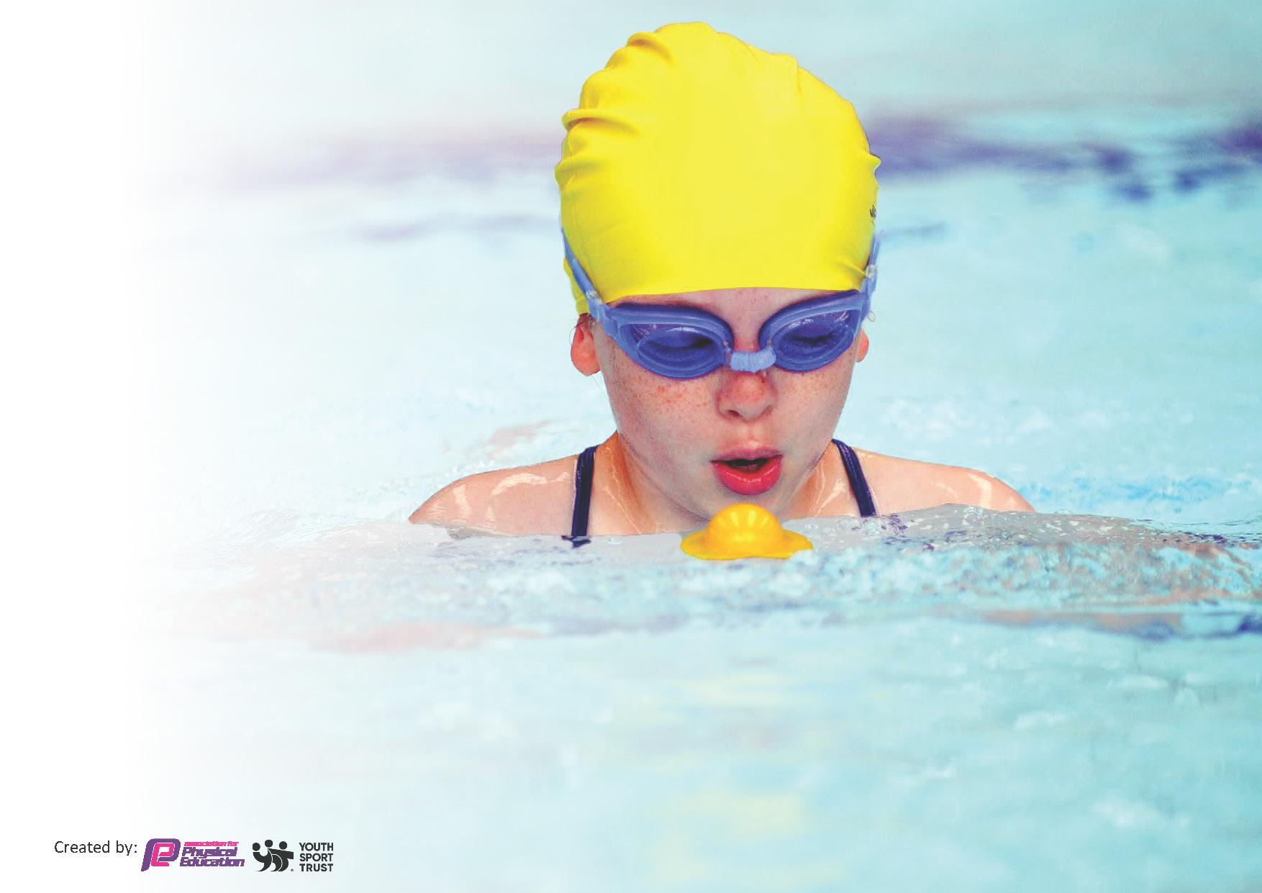
This template can be used for multiple purposes:
by:
- It enables schools to effectively plan their use of the Primary PE and sport premium
- It helps schools to meet the requirements (as set out in guidance) to publish information on their Primary PE and sport premium
- It will be an effective document to support Ofsted inspections enabling schools to evidence progress in Physical Education (PE) and evidence swimming attainment, which forms part of the PE National Curriculum. We would recommend schools consider
the Intent, Implementation and Impact of any spend, as examined within the Education Inspection Framework.

It is important that your grant is used effectively and based on school need.

Schools must use the funding to make additional and sustainable
improvements to the quality of the PE, School Sport and Physical Activity (PESSPA)
they offer. This means that you should use the Primary PE and sport premium to:

- Build capacity and capability within the school to ensure that improvements made now will benefit pupils joining the school in future years
- Develop or add to the PESSPA activities that your school already offers.

The Primary PE and sport premium should not be used to fund capital spend projects; the school’s core budget should fund these. Further detail on capital expenditure can be found in the updated Primary PE and sport premium guidance.

The Primary PE and sport premium guidance, outlines 5 key priorities that funding should be used towards. It is not

necessary that spending has to meet all the key priorities, you should select the priorities that you aim to use any funding towards.

Although completing this template is not a requirement for schools, schools are required to publish details of how they spend this funding. Schools must also outline what the impact this funding has had on pupils’ PE and sport participation and attainment and how any spending will be sustainable in the future. All funding must be spent by 31st July 2024.

The Department for Education has worked closely with the Association for Physical Education (afPE) and the Youth Sport Trust (YST) to develop this template and encourages schools to use it. This template is an effective way of meeting the reporting requirements of the Primary PE and sport premium.
Review of last year’s spend and key achievements (2022/2023)

We recommend you start by reflecting on the impact of current provision and reviewing your previous spend.

Activity/Action | Impact | Comments
Prior to academy status

Key priorities and Planning
This planning template will allow schools to accurately plan their spending.

Action – what are you planning to do | Who does this action impact? | Key indicator to meet | Impacts and how sustainability will be achieved? | Cost linked to the action
Use of SM sports to lead a range of games and activities at afterschool clubs.  External Sports Coaches (Streetwyze/  Huddersfield Giant/Yorkshire Cricket Foundation) | All Pupils- access to a broad range of games & skills  Teaching staff- through good levels of engagement  Offering pupils professional coaching | Key indicator -The engagement of a bigger range of pupils in regular physical activity  Key indicator : Broader experience of a range of sports and activities offered to all pupils.  Competing against children county wide | More pupils meeting their daily physical activity goal, more pupils encouraged to take part in PE and Sport Activities. | 2 sessions per week x 39 week @ £70 pw for Sports coach.  £2730  £1500

Batley Sporting Foundation & Batley Primary School Sports Association  Equipment  Transport  Swimming  Funded sports club | PE specialist to work alongside staff from Y1- Y6 delivering curriculum content- planning, lesson structure and team teaching.  Access to a range of inter school sporting events.  Pupils have the necessary tools  To engage with the curriculum and clubs being delivered in school.  Assist with transportation costs to inter school events  Coach, pool and staffing costs  Free places for children to attend after school sports club | Key Indicator 1: Increased confidence, knowledge, and skills of all staff in teaching PE and sport. Staff developing their expertise to run high quality PE sessions, learning from an expert week by week.  Key indicator 5: Increased participation in competitive sport.  Key indicator 5: Increased participation in competitive sport.  Key indicator 5: increased participation in competitive sport. | Primary teachers more confident to deliver effective PE.  Increased percentage of children accessing competitive sports.  Increased percentage of children who have achieved their ‘1 length’ and water safety certification  Increased percentage of children accessing extra curricular sporting activities. | £1000 annual subscription .  £3000  £2725  £6718  INCLUDED IN SM Sports figure)

Key achievements 2023-2024
This template will be completed at the end of the academic year and will showcase the key achievements schools have made with their Primary PE and sport premium spending.

Activity/Action | Impact | Comments
SM Sports & External Sports Coaches  Deployment of BSF for access to extra-curricular competition and staff CPD. Annual subscription.  New equipment  Dance Activities | Engagement in children in a broader range of physical activities during social times.  Introduction of children to new sports, including Tri Golf in which one team were competition winners  Greater enjoyment and purpose at lunch time.  Development of teacher confidence, watching and working with experienced PE staff members in the Early years of their career as teachers.  Development of staff’s repertoire of warm up activities.  Increased pupil confidence and enjoyment of school and sense of belonging.  AIM academy opportunities for those pupils  Who are able interested and motivated.  Replenishment of old equipment to provide children with the tools they need to best enjoy PE lessons and extra curricular clubs.  Links to the wider curriculum and British values  Engagement of children with ‘dance’ which had not been a pupil favourite. | Cricket, football, basketball and athletics, X Country, Orienteering, Street Dance, Boxing, Netball, Dodgeball, Bikeability & Zumba activities have been popular. Engaging children in fun and competitive activities in a ‘low stakes’ environment.  Linked to lunch time activities, a school cricket team has emerged competing in local and regional events.  SM sports have supervised the development of a child lead sports crew- developing roles and purpose for children beyond the classroom.  Improved understanding of how lessons are structured and how objectives are shared with children.  Working alongside BSF staff, teachers now have greater confidence with the purpose/variety/delivery of warm up  Pupil voice reflects how much children have enjoyed the opportunity to represent school and compete in events against children from other schools in the locality.  Pupil voice- shows this to be one of the hi  Lights of the year- inspiring children to  Think about PE as a career and vocation.  A rolling programme accepting that balls will be lost and that equipment will need replacing due to wear and tear but that we must keep up to stock replenishment to best engage our children with their PE sessions.  Development of pupil confidence in the performance of a dance routine- working to a ‘real’ outcome and a real audience as a whole school.

Swimming Data
Meeting National Curriculum requirements for swimming and water safety.
Priority should always be given to ensuring that pupils can perform safe self-rescue even if they do not fully meet the first two requirements of the National Curriculum programme of study

Question | Stats: | Further context  Relative to local challenges
What percentage of your current Year 6 cohort can swim competently, confidently and proficiently over a distance of at least 25 metres? | Stats are based on the curriculum year 2022/2023 as stats based on 2023/2024 have not been published:  43% | Use this text box to give further context behind the percentage.  e.g., 30% - we are struggling to get pool space due to our local pool closing so we have had to use a much smaller local school pool. We have had to limit the number of pupils attending swimming lessons during one term which means some pupils have attended fewer swimming lessons than others.  Three new children to our school arrived having no prior experience of swimming
What percentage of your current Year 6 cohort can use a range of strokes effectively [for example, front crawl, backstroke, and breaststroke]? | 37% | Use this text box to give further context behind the percentage.  e.g., Even though your pupils may swim in another year please report on their attainment on leaving primary school at the end of the summer term 2024

What percentage of your current Year 6 cohort are able to perform safe self-rescue in different water-based situations? | 33% | Use this text box to give further context behind the percentage.
If your schools swimming data is below national expectation, you can choose to use the Primary PE and sport premium to provide additional top-up sessions for those pupils that did not meet National Curriculum  requirements after the completion of core lessons. Have you done this? | No | We did not do this due to the completion of their swimming sessions finishing in July each academic year.
Have you provided CPD to improve the knowledge and confidence of staff to be able to teach swimming and water safety? | No | Specialist coaches provide swimming coaching

Signed off by:

Head Teacher: | Ben Smith & Jonathan Sharp
Subject Leader or the individual responsible for the Primary PE and sport premium: | Ben Smith & Karen Halmshaw
Governor: | NA
Date: | 29/07/2024

