

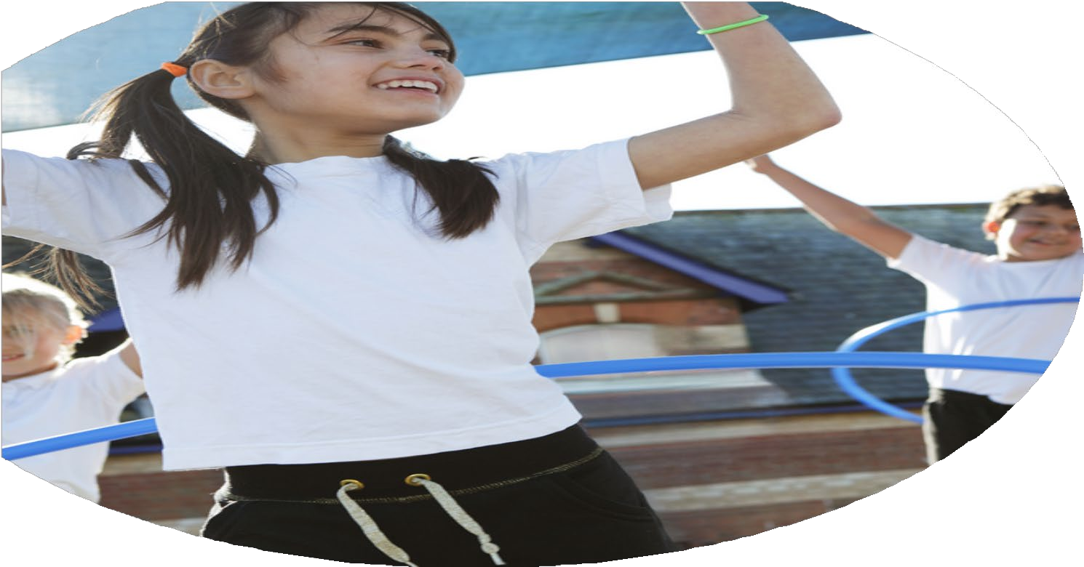
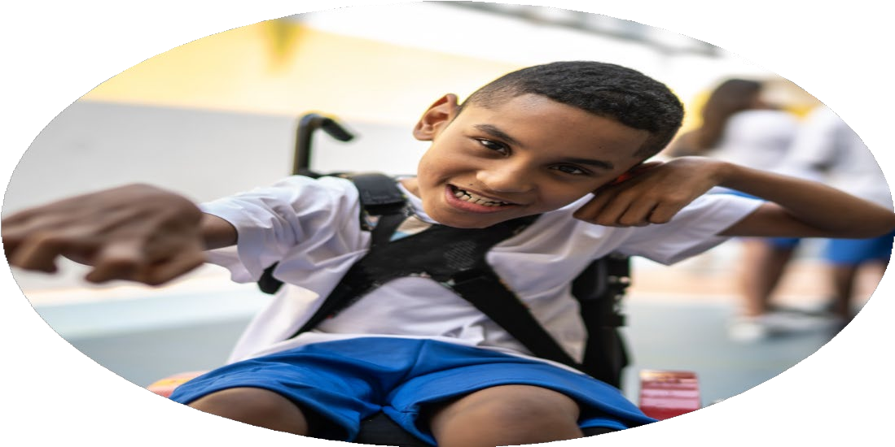
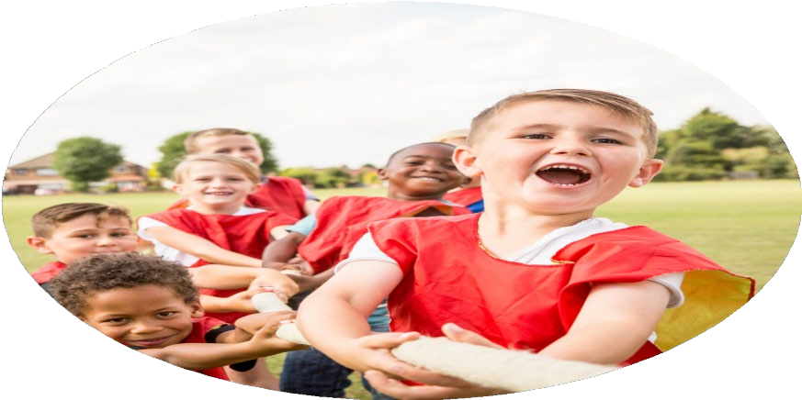



PE Funding

Evaluation Form

Commissioned by

Created by

Images courtesy of Youth Sport Trust

PE Funding Evaluation Form

It is intended that this template should be used as preparation for the completion of the statutory digital reporting tool being introduced this academic year. You can upload data (including swimming) from this template onto this platform once it becomes accessible.
Before you decide how you are going to use the funding for this academic year you should reflect and evaluate the impact of your use of the funding in 2023/24.
All spending of the funding must conform with the terms outlined in the Conditions of Grant document. The template is a working document that you can amend/update during the year.
Based on your evaluation of last year’s funding you should decide what you intend to do this academic year, how you will do it, and what impact you expect it to have.

It is important that the funding is used effectively and based on your school’s needs.
You must use the funding to make additional and sustainable improvements to the PE and sport in your school. You must develop and add to the PESSPA activities that your school already offers.

Summative digital reporting from June 2025 will continue to include swimming and water safety information therefore funding can be used to provide top-up lessons where necessary to ensure pupils meet national curriculum swimming requirements.

We recommend that you start by reflecting on the impact of current provision and reviewing your previous spend

What went well? | How do you know? | What didn’t go well? | How do you know?
- Staff increased their knowledge of teaching PE  - Children have increased their participation of physical activity eg. Active playtimes, increase of the amount of physical activity extra-curricular clubs  - The profile of PE has raised with the implementation of a new curriculum  - Broader experience of a range of activities has increased due to the varying amount of PE contexts within the curriculum and sports on offer  - Increased participation in competitive sports has maintained through a cycle of intra sports competitions with additional inter competitions supplementing this offer | Informal staff survey, pupil voice  Pupil voice, Improved behavior, personal development has been used to target children not engaged in physical activities  Pupil voice, progressive curriculum, play leaders informal discussions  Personal development tracker, Intra sports calendar | - Inter competition participation could have been increased further  - Assessment structure of PE to be established and implemented | The number of external competitions attended  Currently the focus has been on the delivery of PE sessions with no formal way of recording

What are your plans for 2025/26? | How are you going to action and achieve these plans?
Intent | Implementation
Rebuild the school’s level of participation in sports competitions and festivals  Use the Personal Development tracking tool to find out which children are not physically active and use this as a starting point for finding out which activities children would like to do, what times suit our children  In consultation with the Behaviour Lead, and the children themselves, draw up personal plans for children who are having difficulty maintaining appropriate behaviours for learning in school, using sport to motivate and engage.  Ensure that all children have the opportunity to participate in outdoor and adventurous activities off-site | Plan the school sporting year with support from the School Games Organiser; plan the calendar, curriculum and clubs to train for competitions; organise transport and staffing; liaise with other schools  Aim to provide one external Sports competition/activity event per year group  Buy in PE HLTA for staff CPD training (1 day equivalent) for increase staff knowledge  Children gain experience of meeting peers; staff understand how competitions are set up and run; children learn resilience, gamesmanship  Children to be offered a wide range of engaging and educational PE and sport experiences that motivate them and encourage them to be active for life  Personalised timetables, building more opportunities for physical activity, and increasing challenge are offered to help children to enjoy school, regulate their behaviour and emotions and allow the ethos of the school to remain calm and focused.  By paying for the coach travel to activities off site, the trips become accessible to pupils who otherwise would not be able to attend.

What impact/intended impact/sustainability are you  expecting? | How will you know? What evidence do you have or  expect to have?
Children attending Batley Parish will increase their amount of inter competitive participation building a history of certain year groups competing in particular sports  Targeted children will help to further ensure that all children take part in at least one additional physical activity. The range and repertoire of physical activity opportunities continues to broaden across a variety of different times across the school day  Physical activity is used to support the behavior of targeted children  All children participate in at least one outdoor adventurous activity off site | Participation numbers of inter competitions will increase and be evident on a personal development tracker  Using the personal development tracker evidence will detail the participation and the type / time of participation carried out  Individual Behaviour Plans or SEND documentation identifies specific areas of need that have been met through the use of physical activity  Personal development tracker identifies the opportunities off site that children have engaged with

What impact/sustainability have you seen? | What evidence do you have?
A significant impact associated with teacher confidence has been attributed to the implementation of the new PE scheme. All teachers are teaching PE. A wide range of PE contexts are being taught by following a progressive and spiral curriculum that allows teachers and children to develop confidence.  Competitive sports have increased for all children with the introduction of Intra Sports competitions allowing children to compete using the introduction of ‘house teams’ embedding previously taught skills in a format in which competition is encouraged  A range of sports have been accessed by an increasing number of children by utilising the new curriculum alongside a greater repertoire of extra-curricular sporting clubs and opportunities during lunchtimes by targeting specific children | Informal staff survey / discussions  PE CPD sessions  Extra support provided for selected year group’s PE sessions  Pupil voice  Personal development tracker  Pupil voice

