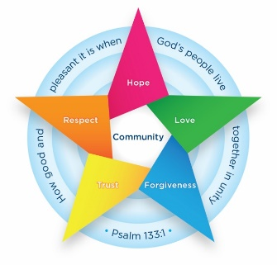
Class 1 Newsletter
Happy New Year! I hope that you have all had a lovely break over the Christmas holidays and are ready to get back into a routine. Please find below a brief summary of what we will be learning this half term. Should you have any queries please don’t hesitate to speak to me before or after school to arrange a meeting.
Kind Regards, Miss Mason and Mrs Mulla
Kind Regards, Miss Mason and Mrs Morton
Kind Regards, Miss Mason and Mrs Morton

Kind Regards Miss Y
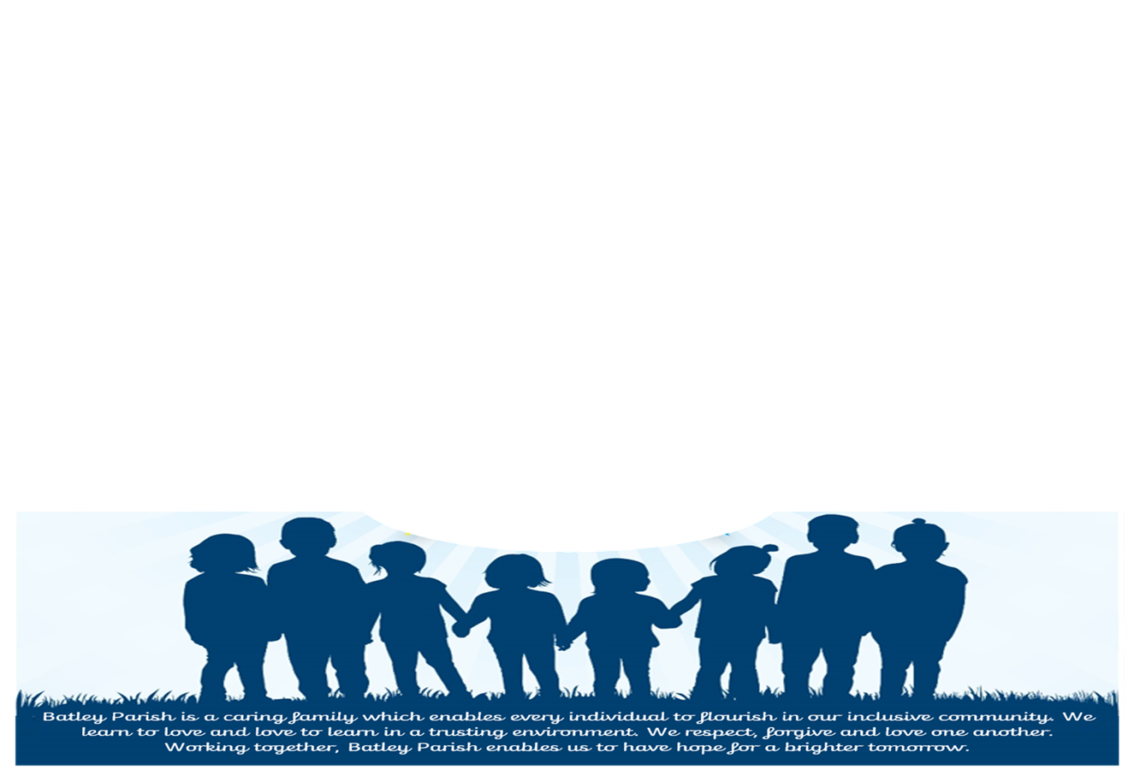
English
This half term we are focussing on stories based on toys. We will be starting this week with a superhero Traction Man who enjoys saving the day. We will also be reading The Adventures of the Dish and the Spoon later in the half term. We will be writing character descriptions and creating comic strips to retell the action -packed story. Children are practising their sequencing of sentences and trying to include ‘and’ to create a longer sentence. We will be using adjectives in our writing to describe the characters and their feelings.
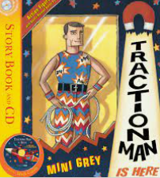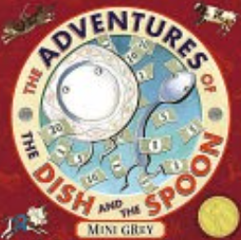

Class Information
- PE – Wednesday and Thursday. Children come to school these days dressed in their PE kit that includes trainers and appropriate clothing suitable for outdoor activities and for the weather.
- Homework – Sent home each Friday. This will be 5 spellings each week, a maths task that has been taught in school previously for them to practise with you at home and a key question as a revisit from prior learning.
- Reading – You will be sent home with 2 phonics reading book, a reading record and a library book. Reading books will be changed alongside their phonics sessions and library books can be changed every Friday.

How can parents help at home?
Please try to read regularly with your child as they will have two different books sent following on from phonics sessions.
Please keep all books in your child’s book bag each day as adults may read with them in school. Thank you.

Geography- What is the weather like in the U.K?
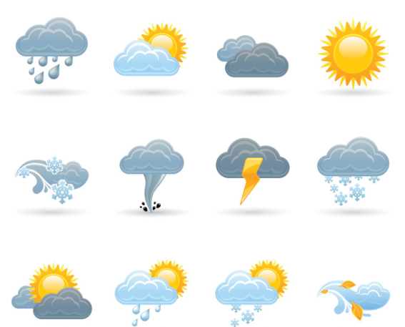
Children will learn where the U.K is and which countries are part of the United Kingdom. They will learn how the weather changes between seasons and have the opportunity for some outdoor learning to observe the weather and to use a compass.
Design and Technology- Puppets
Children will learn how to join materials together using a variety of techniques to make a hand puppet.
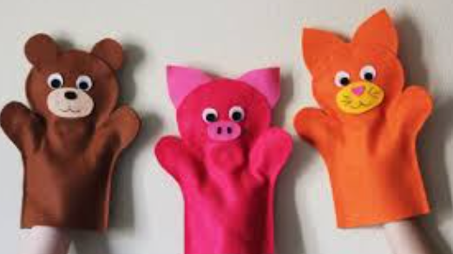

Collective Worship
This half term our collective worship focus is our Christian value: Love. Children will have a challenge each week based on this, which will be set during assembly time.

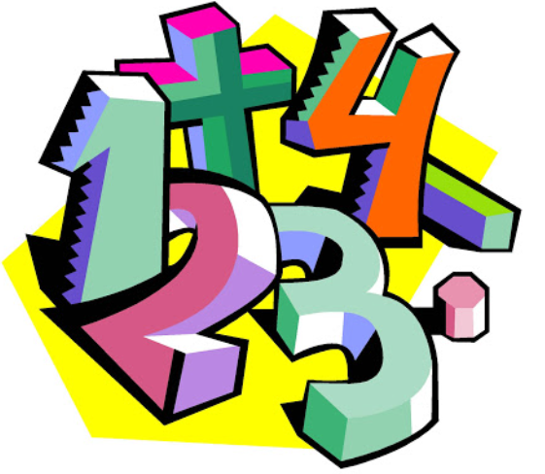
Maths
In Maths this half term we will be adding to our subtraction and addition knowledge. We will also be extending our place value skills of partitioning and representing numbers. Children will then have the ability to order and compare numbers based on how many tens and ones a number is made up of.

