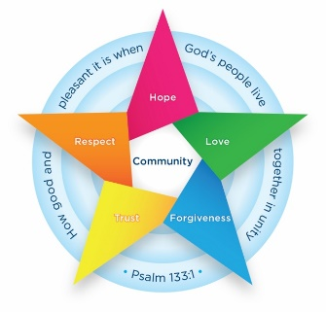
Class 1 Newsletter
We hope that you have all had a lovely half term break and ready to be back to school. Please find below a brief summary of what we will be learning this half term. Should you have any queries please don’t hesitate to speak to me before or after school to arrange a meeting. Kind Regards, Miss Mason and Mrs Mulla

Kind Regards, Miss Mason and Mrs Morton

Kind Regards Miss Y
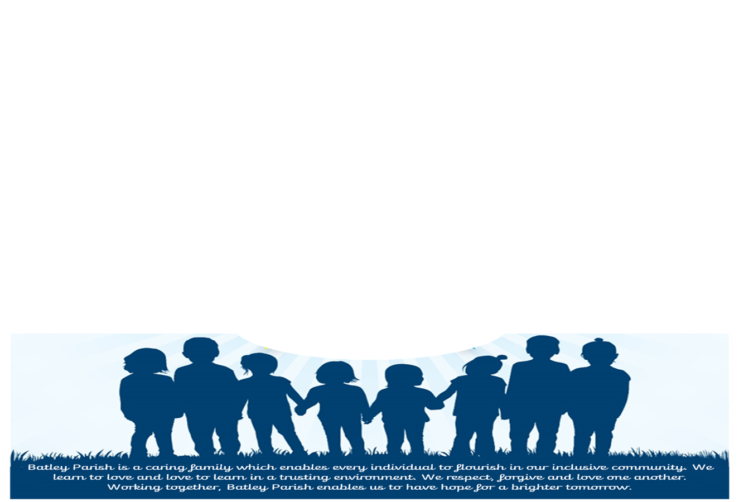
Collective Worship
This half term our collective worship focus is our Christian value: Forgiveness. Children will have a challenge each week based on this, which will be set during assembly time.

History- How have toys changed?
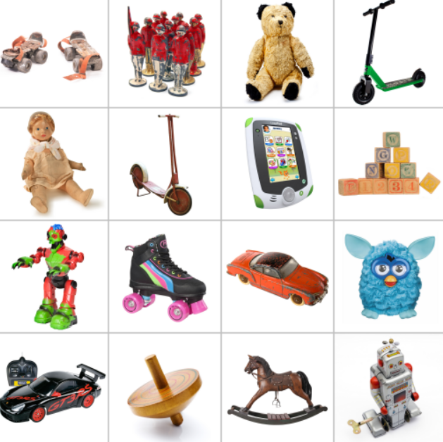
We will start by children having the opportunity to bring in their favourite toy to look at the variety of what modern toys do. Children will learn about the change in toys over time, for example technology and the move from push and pull toys. We will visit Abbey House to complete a toy workshop, focusing on old toys.
Art and Design- Colour Splash
Children will revisit colour mixing and be able to use primary colours to make secondary colours. Children will explore using different sized brushes to make different marks.
Class Information
- PE – Wednesday and Thursday. Children come to school these days dressed in their PE kit that includes trainers and appropriate clothing suitable for outdoor activities and for the weather.
- Homework – Sent home each Friday. This will be 5 spellings each week, a maths task that has been taught in school previously for them to practise with you at home and a key question as a revisit from prior learning.
- Reading – You will be sent home with 2 phonics reading book, a reading record and a library book. Reading books will be changed alongside their phonics sessions and library books can be changed every Friday.

English
This half term we will be starting with The Adventures of the Dish and the Spoon and writing about the adventures that they went on. We then will move onto the Tiger who came to Tea. We will continue our sentence writing to ensure we are using capital letters to start a sentence and for names of people, finger spaces and full stops. We are going to encourage longer sentences using and. Children have been practising each day to count how many words are in their sentence and then reading their work back.
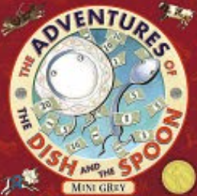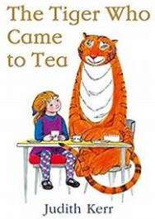

How can parents help at home?
Please try to read regularly with your child as they will have two different books sent following on from phonics sessions.
Please keep all books in your child’s book bag each day as adults may read with them in school. Thank you.

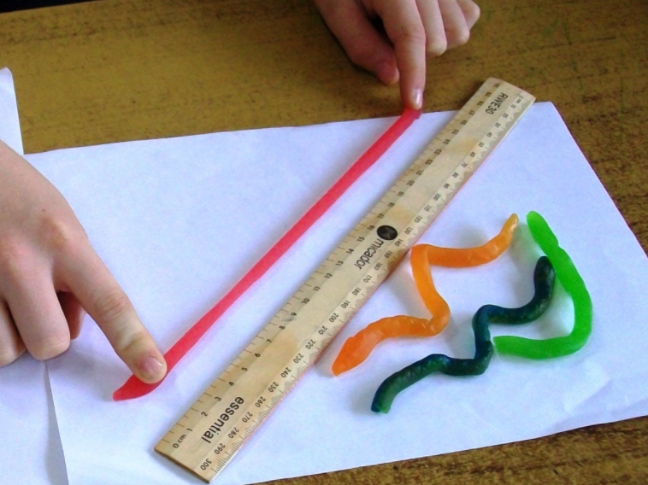
Maths
In Maths this half term we will be continuing to build on our place value knowledge with numbers up to 50. We will then be adding on to our skills from Reception to learn how to measure and compare length, height, weight and capacity.
