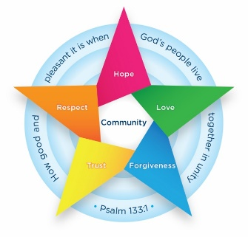
Class 2 Newsletter
Welcome back- I hope that you have enjoyed the break. Last half term the children really enjoyed all of our learning. They particularly enjoyed making biscuits and adding their own secret ingredient! Please find below a brief summary of what we will be learning this half term. Should you have any queries please don’t hesitate to speak to me before or after school.
Kind Regards, Mrs Aka

How can parents help at home?
- Reading regularly and recording in reading record – including the library books.
- Encourage children to join their handwriting.
- Practise counting in 2s, 3s, 5s and 10s
- Please encourage your child to practise checking their writing at home and ensuring it includes capital letters and full stops.
Maths
In Maths, we will be continuing our learning about multiplication and division. We will then finish the term with some length and height learning.
We now complete an extra maths session each day. This is straight after lunch and builds up fluency in numbers. The children have been learning all about building numbers up to 10 using odd and even numbers recently.

English
This term, we will be learning about carnivals. We will be creating some setting and character descriptions and enjoying clips from carnivals as well as the story ‘Charlie’s Magical Carnival’. Our experience day will involve making a mood board to show what we know and what we want to know about carnivals. We will be learning how to write setting descriptions.

Class Information
- PE – PE will take place on Tuesday and Thursdays.
- Homework – this will be sent home every Friday. Please return the following Friday.
- Reading – Try to read with your child every day and please record this in their reading diary. Some children do not have a phonics book now so please encourage them to read their library book themselves and record this.
- Knowledge Organisers – Please find attached some subject knowledge organisers for this half term. These summarise the facts that children in Class 2 are expected to learn in lessons this half term.

Design and Technology
This half term we will be learning all about fairgrounds and creating a ferris wheel.

RE
During our RE learning this half term we are focusing on places that are sacred to believers. We will look at different places of worship and why these are so special to people.

PSHE
Our focus for this half term is Citizenship. We will be learning about rules and expectations in school and roles within the community. If you work in the local community we would welcome you coming to share your role with the children to support their learning! Please let me know if you would be interested in this!

Geography
The children will learn all about why our world is wonderful.

Science
This half term we are learning about animals and their habitats. We will be looking at why some animals are better suited to certain habitats than others.

