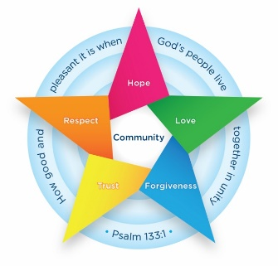
Class 2 Newsletter Summer 1
We hope everyone had a wonderful Easter break, filled with relaxation, fun, and perhaps a little chocolate indulgence! As we welcome you back to school, we are excited to embark on the final stretch of this academic year. As always please do not hesitate to contact me if you need anything!
Kind Regards, Mrs Aka

Class Information
- PE – PE will take place on Tuesdays and Thursdays.
- Homework – this will be sent home every Friday. Please return the following Friday.
- Reading – Try to read with your child every day and please record this in their reading diary. Some children do not have a phonics book now so please encourage them to read their library book themselves and record this.
- Knowledge Organisers – Please find attached some subject knowledge organisers for this half term. These summarise the facts that children in Class 2 are expected to learn in lessons this half term.

Art and Design
This unit focuses on teaching children to learn that pieces of clay can be joined using the ‘scratch and slip’ technique. We will be learning all about the sculptor Ranti Bam.
RE
This half term the children will be thinking about what news Jesus brings.

PSHE
The children will learn about Economic Wellbeing. They will learn all about money, banks, and different ways to live in our community!

History
The children will learn all about what a monarch is. They will learn about what it means to be a king or queen and what a coronation is. As well as, royalty from the past.

Myths
The children will be learning all about myths and legends. They will learn how to create rhythms and arrange them in a particular order or structure and identify the structure of a piece of music and write it down.

How can parents help at home?
- Reading regularly and recording in reading record – including the library books.
- Encourage children to join their handwriting.
- Practise counting in 2s, 3s, 5s and 10s
- Please encourage your child to practise checking their writing at home and ensuring it includes capital letters and full stops.
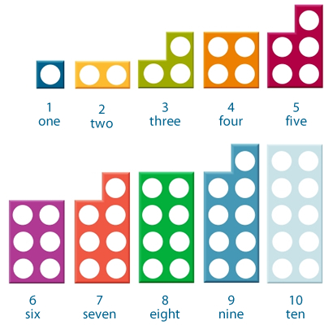
Maths
In Maths, we will be starting our learning on fractions and time!
We will also be continuing with our extra mini-maths after lunch.

English
This term, I have bought some lovely books for us to share! We will be starting with ‘The Storm Whale’ before moving onto hopefully writing a recount of a school trip which I am currently planning. The children will be writing a letter to thank Noi (in the Storm Whale) for being kind to the whale. We will be working really hard on handwriting, spelling and presentation.

