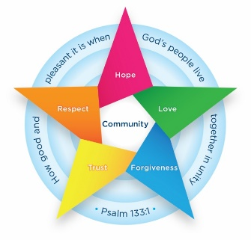
Class 5 Newsletter Summer 1
I am excited to be joining Batley Parish as the Year 5 class teacher this Easter. Starting with a residential was amazing! Please do not hesitate to contact me if you need anything or have any questions!
Kind Regards, Mrs Somerville

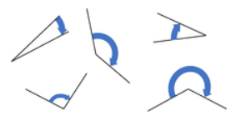
Maths
In Maths, we will be developing our understanding of angles, calculating missing angles on straight lines and in circles.
We will work on moving shapes through translation and using rotational symmetry.

Class Information
- PE – PE will take place on Tuesdays and Wednesdays.
- Homework – this will be sent home every Tuesday. Please return the following Friday.
- Reading – Try to read with your child every day, or at least 3 times a week, and please record this in their reading diary. Reading diaries will be collected in on Friday lunchtime and reading acknowledged.
- Knowledge Organisers – Please find attached some subject knowledge organisers for this half term. These summarise the facts that children in Class 5 are expected to learn in lessons this half term in History, Science and RE.

How can parents help at home?
- Reading regularly and recording in reading record – including the library books.
- Encourage children to join their handwriting.
- Practise counting in 7s, 8s and 9s; and times tables up to 12 x 12
- Let your children help in the kitchen, learning basic food hygiene, how to stir and how to chop safely; and how to clear up after themselves.

English
This term, we are starting our writing journey by looking at biographies and writing a biography of Mrs Somerville!

We will move on to writing a formal letter addressing sewage leaks polluting our streams and rivers; and then a narrative based on a short film set in a post-apocalyptic world.

DT
This unit focuses on teaching children to consider the food that they eat. They will be learning where the ingredients come from to make spaghetti bolognese, practising their cookery skills of chopping and stirring – and making their own!
RE
This half term the children will be thinking about what would Jesus do in different situations and what their own responses would be

PSHE
The children will learn about Economic Wellbeing. They will learn about the choices that have to be made with money.

History
The children will learn all about the Golden Age of the Greek civilisation, learning about the different gods and goddesses and how they were worshipped. They will learn about the development of democracy and the ways in which people advanced their thinking about thinking. The legacy of the Greeks and their impact on our lives today will be considered.

