

Batley Parish CE Primary Academy

SEND Policy

September 2026

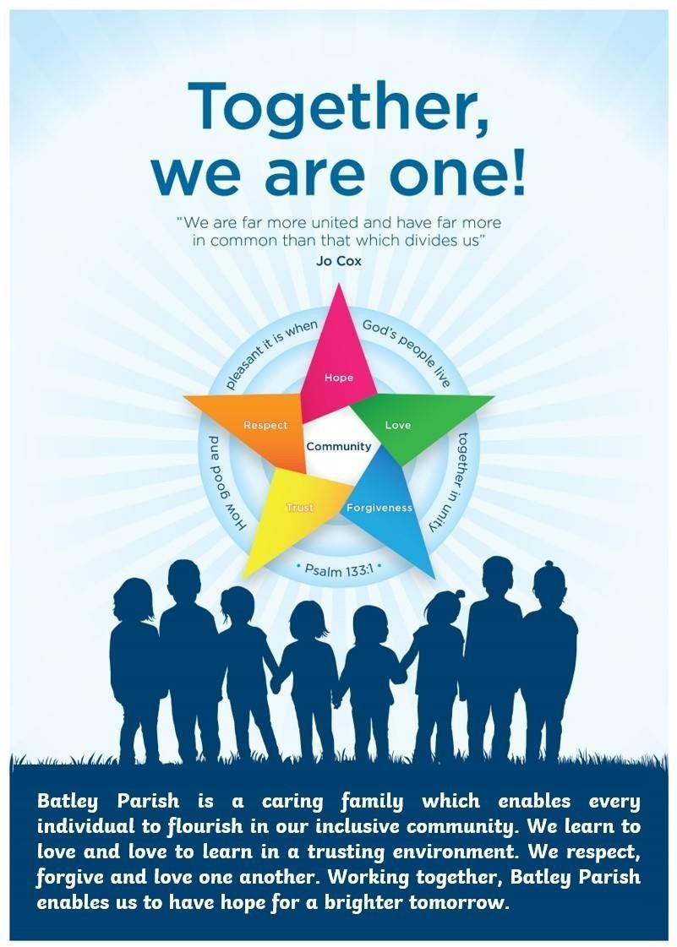

Introduction

At the heart of the ethos at Batley Parish CE Primary Academy lies the Christian faith. From this stems the importance of nurturing and developing the skills and objectives that will enable all children to flourish into tolerant, caring adults who are well-prepared for the various stages of life. At Batley Parish, we believe that all children are individuals and are entitled to high-quality teaching and expectations, provided through a broad and balanced curriculum. This ensures they can fulfil their maximum potential. We recognise that a 'Special Educational Need or Disability' often arises from the interaction between children, their environment, their culture, and their school. We aim to minimise learning difficulties through quality provision, delivered via a relevant and scaffolded curriculum in a secure and encouraging environment that promotes physical, mental, and emotional health and well-being.

This policy has been formed by Mrs Rebecca Aka, SENDCO, in consultation with staff and governors, having regard to the Special Educational Needs and Disability Code of Practice: 0 to 25 Years.

Contact

Mrs. Rebecca Aka – NA SENCO Award
Email: office@batleyparish.enhanceacad.org.uk Telephone: 01924 326361

Long-Term Aims of this Policy

- To work within the guidance laid down in the SEND Code of Practice 2014.
- To identify and provide appropriate provision for pupils with SEND and additional needs.
- To operate a whole-school approach to managing and supporting SEND that takes into account all a pupil’s needs (Assess, Plan, Do, Review model).
- To ensure parents/carers clearly understand how the school supports children and young people with SEND and their own involvement in this process.
- To provide support and advice for all staff working with pupils with SEND.

Identification of SEND

Children and young people are identified as having SEND if they have a learning difficulty or disability requiring special educational provision. This aligns with the broad areas of need outlined below:

- Communication and Interaction (including Autism Spectrum Conditions)
- Cognition and Learning
- Social, Emotional, and Mental Health Difficulties
- Sensory and/or Physical Needs

A child of compulsory school age or a young person has a learning difficulty or disability if they:

- Have a significantly greater difficulty in learning than the majority of their peers of the same age;
- Have a disability preventing or hindering them from accessing facilities generally available to others of the same age in mainstream schools or post-16 education.
- Other factors may impact progress and attainment, such as attendance and punctuality, English as an Additional Language, being a Child Looked After, health and welfare, being in receipt of Pupil Premium, or disability. (Note: Under the Equality Act and the Code of Practice, schools and settings must make ‘reasonable adjustments’—this alone does not constitute SEND).

Special educational provision refers to educational or training provision that is additional to or different from what is generally provided for other children or young people of the same age in mainstream schools.

Many children and young people with SEND may meet the Equality Act 2010 definition of disability: ‘a physical or mental impairment with a long-term and substantial adverse effect on normal day-to-day activities.’ Schools and other institutions have the following duties towards disabled children and young people:

- They must not directly or indirectly discriminate against, harass, or victimise disabled children and young people.
- They must make reasonable adjustments, including auxiliary aids and services, to ensure disabled children and young people are not at a substantial disadvantage compared to their peers.
- This duty is anticipatory, requiring proactive consideration of adjustments needed to avoid disadvantage.

Graduated Response

Class and subject teachers are responsible for the progress and development of children and young people in their class. They oversee the work of any support staff involved and collaborate with specialist staff as needed. Planning accounts for additional adult support, which is discussed with staff. However, intervention and support do not replace high-quality teaching.

SEND support follows a four-part cycle (Assess, Plan, Do, Review), refining decisions and strategies with a growing understanding of pupils’ needs. Successive cycles employ more detailed approaches, frequent reviews, and specialist expertise to tailor interventions to pupils' SEND.

Assess

Class teachers and the SENCO conduct a thorough analysis of a pupil’s needs, considering the teacher's assessment, previous progress and attainment, and the school’s core approach to pupil progress, attainment, and behaviour. National data, parents’ views, pupils’ own insights, and advice from external support services (if relevant) are also incorporated. Concerns raised by parents are recorded.

This assessment is reviewed regularly to match support and intervention to needs, address learning barriers, and develop a clear picture of interventions and their impact. If external professionals are not already involved, the SENCO will contact them with parental consent.

Plan

When SEND support is decided upon, parents are notified. The teacher and SENCO agree, in consultation with parents and the pupil, on adjustments, interventions, and support needed. This includes the expected impact on progress, development, or behaviour and a clear review date.

All staff working with the pupil are informed of their needs, desired outcomes, support measures, and relevant teaching strategies.

Do

The class teacher works with the child daily, collaborating closely with teaching assistants or specialist staff. The SENCO supports further assessment of the pupil’s strengths and weaknesses, advises on problem-solving, and ensures effective implementation of support strategies.

Review

Support effectiveness and its impact on the pupil's progress are reviewed by the agreed date. Evaluations consider the pupil’s and parents’ views and feed into revising interventions and strategies. Where pupils have an EHC plan, the local authority conducts annual reviews as a minimum.

Criteria for Exiting the SEND Register

Pupils are regularly monitored, both within the whole-school framework and with respect to their additional support. Decisions about removing pupils from the SEND Register are made in partnership with parents/carers at the end of each monitoring cycle.

Requesting an Education, Health, and Care (EHC) Needs Assessment

When, despite appropriate action and support, a pupil fails to make expected progress, the school or parents may consider requesting an EHC needs assessment. Evidence of at least two review cycles of the Assess, Plan, Do, Review model will be required by the local authority.

Supporting Families and Pupils

The partnership between families and the school is crucial to a child’s educational progress. At Batley Parish, we work closely with parents, fostering early, positive communication to enable active parental involvement. Parents will:

- Be encouraged to discuss concerns with staff, including the class teacher, SENCO or Headteacher.
- Receive regular updates about additional support within the SEND framework.
- Be invited to share their views during reviews or meetings concerning their child.
- Access information, advice, and support during assessments and decisions regarding SEND provision.

Transition

When a child leaves Batley Parish to transfer to another school, the SENCO will forward relevant information about the child’s needs and the efforts we have made to meet them. Where a pupil is moving to a local school, this will be achieved, wherever possible, by inviting the SENCO for the receiving school to the last review meeting held under the staged procedures described above. A range of transition activities will also be arranged for children with additional needs.

Supporting Pupils at School with Medical Conditions

At Batley Parish, we recognise that children and young people with medical conditions should be properly supported so that they have full access to education, including school trips and physical education. Some children and young people with medical conditions may be disabled, and where this is the case, the school will comply with its duties under the Equality Act 2010.
Please refer to our Medical Needs Policy.

Roles and Responsibilities SEND Governor
As SEND Governor, Zabair Hussain has a particular interest in the development and implementation of the SEND Policy. He is made aware of all pupils on the SEND register and the number and range of pupils with SEND through regular contact with the SENDCO.
In line with the Code of Practice, the SEND Governor will:

- Help to raise awareness of SEND issues at governing board meetings.
- Monitor the quality and effectiveness of SEND and disability provision within the school and update the governing board on this.
- Work with the senior leadership team to determine the strategic development of the SEND policy and provision in the school.

Special Needs and Disabilities Co-coordinator (SENDCO)

Rebecca Aka (SENDCO) will:

- Work with the Executive Head teacher/Head of School and SEND Governor to determine the strategic development of the SEND policy and provision in the school.

- Have day-to-day responsibility for the operation of this SEND policy and the coordination of specific provision made to support individual pupils with SEND, including those who have EHC plans.
- Provide professional guidance to colleagues and work with staff, parents, and other agencies to ensure that pupils with SEND receive appropriate support and high-quality teaching.
- Advise on the graduated approach to providing SEND support.
- Advise on the deployment of the school’s delegated budget and other resources to meet pupils’ needs effectively.
- Be the point of contact for external agencies, especially the local authority and its support services.
- Liaise with potential next providers of education to ensure that the school meets its responsibilities under the Equality Act 2010 with regard to reasonable adjustments and access arrangements.
- Ensure the school keeps the records of all pupils with SEND up to date.
- The SENCO will ensure that the SEND register, One Page Profiles, My Support Plans, and SEND Integris records are properly kept and available as needed. Parents are welcome to have access to their child's records after consultation with the Executive Head teacher/Head of School and the SENDCO.
- For children taken off the register/SEND Support, it remains the responsibility of the class teacher to monitor their progress and alert the SENCO if further concerns arise.

Headteacher

The Headteacher will:

- Work with the SENCO and SEND Governor to determine the strategic development of the SEND policy and provision within the school.
- Have overall responsibility for the provision and progress of learners with SEND and/or a disability.

Class Teachers

Each class teacher is responsible for:

- The progress and development of every pupil in their class.
- Working closely with any teaching assistants or specialist staff to plan and assess the impact of support and interventions and how they can be linked to classroom teaching.
- Working with the SENCO to review each pupil’s progress and development and decide on any changes to provision.
- Ensuring they follow this SEND policy.
- Leading reviews with families for One Page Profiles and IAPDR plans.
- Welcoming other professionals into their classroom to work with children.
- Raising a concern using a ‘Cause for Concern’ sheet where there are issues regarding a child’s need, progress, or attainment.

Resources

The Head of School and Executive Head teacher will manage the allocated funds and ensure that the best use is made of these resources. This will be achieved by prioritising needs through the procedures described below and ensuring that, wherever possible, children are appropriately grouped to optimise the use of staff time (teaching and non-teaching) and equipment.

Each school is responsible for maintaining a ‘notional budget’ to cater sufficiently for the special educational needs of the children and young people within their school.

Schools Block Funding: Contribution of up to £6k for additional support required by children and young people with high needs, from the notional SEND budget.

High Needs Top-Up: Top-up funding from the LA to meet the needs of individual children and young people with EHC plans.

Communication

Termly reviews are held for children on the SEND Register at the One Page Profile, IAPDR, and EHCP levels. These reviews currently take the form of collaborative workshops where all members of staff working with the child, along with parents, meet to share progress and discuss next steps. Views and attendance from other services are also welcomed. The documentation and process takes into account the children’s views as they have an opportunity to reflect and respond.

Rebecca Aka, SENDCO, is responsible for communicating and liaising with a wide range of outside agencies, including:

- Educational psychology
- Early Years SEND (Portex)
- Neurodevelopment Services
- Speech therapists
- Behaviour support teachers
- Teachers for the hearing impaired/ visually impaired/ physically impaired
- Specialist outreach staff
- Physiotherapists
- Occupational therapists
- Children and Adolescent Mental Health Service (CAMHS)

Paperwork, plans, and reports are held electronically on our secure server, ensuring up-to-date information can be added efficiently. The SENCO and class teachers have access to this server to ensure that provision and support for individual pupils is kept up to date and confidential.

Reviewing the Policy

This policy will be reviewed annually, unless changes in legislation or within the school necessitate an earlier review.

Facilities, Physical Access, and Accessibility

Although there are no specialist facilities for pupils with SEND at Batley Parish CE Primary Academy, we provide:

- Access ramps to facilitate entry into the building and playgrounds.
- A single-storey building layout.
- A toilet for disabled use.
- Carpeted areas in all rooms.

Our Accessibility Plan addresses improvement in access to:

- The curriculum
- The physical environment
- The provision of information
- This plan is reviewed annually, barriers are identified, and actions are planned to remove them.

Complaints Procedure

Concerns or complaints should initially be discussed informally with the class teacher and/or SENCO. Complaints will then be addressed in line with the school complaints policy.

For further action, please see the Kirklees Complaints Procedure. KIAS is also available for advice.

Bullying

At Batley Parish CE Primary Academy, we take a whole-school approach to mitigating the risk of bullying, developing independence, and building resilience in our pupils with SEND. Please refer to our Anti-Bullying Policy, Behaviour Policy, and Safeguarding Policy.

Appendices
Special educational needs and disability code of practice: 0-25 years (2014) The Children and Families Act 2014
SEND Co-coordinator Handbook - School SEND Policy

Excellence for all children - Meeting Special Educational Needs - (DFE 1997). Education Act 1997 Health Act 1999
Children’s Act 2004

Special Educational Needs and Disability Act 2001 Disability Discrimination Act 2005
Race Relations Amendment Act 2001
Childcare Act 2006
National Curriculum 2014

Guidance for schools- School based provision for pupils SEND Lamb Inquiry – March 2008
The Equality Act 2010

The Mental Capacity Act 2005

