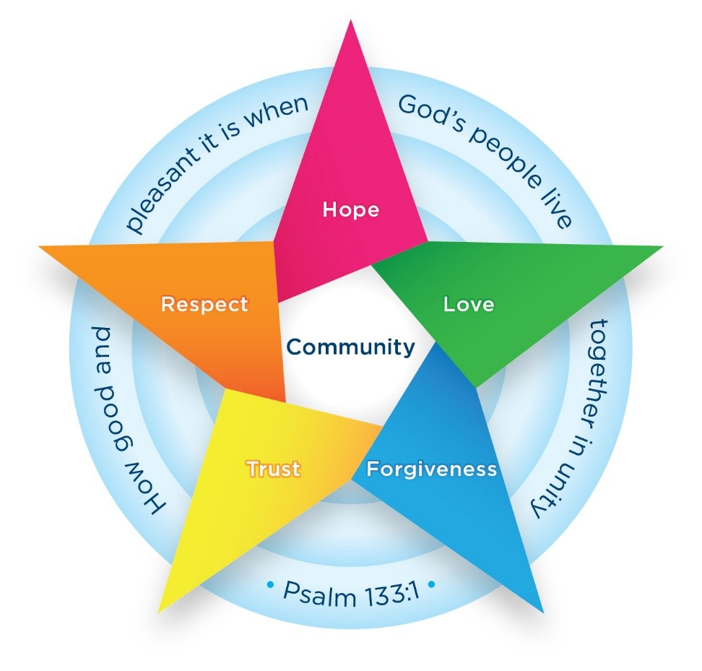

Batley Parish CE Primary Academy

Behaviour Policy

September 2026

At Batley Parish Primary Academy, we believe that, in order to achieve their full potential, all children have the right to be safe and happy in school. Our application of positive behaviour management strategies is a partnership between school staff, pupils and parents/carers. It is based on a belief that all members of that partnership deserve to be treated fairly, listened to and valued as individuals. The school has created clear guidelines for acceptable behaviour based on rewarding consistently positive behaviour. However, we recognise that conflicts do occur. Our staff are trained in the use of restorative practice and use this strategy to resolve problems. There is also a clear framework for identifying consequences for unacceptable behaviour. This policy is designed to promote good behaviour, rather than merely deter inappropriate behaviour.

- Aims and objectives

To ensure that:
- All members of our school community feel valued and respected.
- To create a caring and harmonious community, whose values are built on mutual trust and respect for all, rooted in our Christian values of community, hope, love, trust, forgiveness and respect.
- To promote and advance good relationships and positive behaviour.
- Ensure that rewards are equitable and consequences are consistently applied.
- To promote consistency in the way we manage challenging situations.
- To help children take increasing responsibility for their own behaviour, therefore becoming positive, responsible and increasingly independent members of the school community and wider community.

This policy aims to:
- Provide a consistent approach to behaviour management;
- Define what we consider to be unacceptable behaviour, including bullying and discrimination;
- Outline how pupils are expected to behave;
- Summarise the roles and responsibilities of different people in the school community with regards to behaviour management;
- Outline our system of rewards and sanctions.

2. Legislation and statutory requirements

This policy is based on advice from the Department for Education (DfE) on:
- Behaviour and discipline in schools
- Searching, screening and confiscation at school
- The Equality Act 2010
- Keeping Children Safe in Education
- Use of reasonable force in schools
- Supporting pupils with medical conditions at school

It is also based on the Special Educational Needs and Disability (SEND) Code of Practice

In addition, this policy is based on:
- Schedule 1 of the Education (Independent School Standards) Regulations 2014; paragraph 7 outlines a school’s duty to safeguard and promote the welfare of children, paragraph 9 requires the school to have a written behaviour policy and paragraph 10 requires the school to have an anti-bullying strategy
- DfE guidance explaining that academies should publish their behaviour policy and anti-bullying strategy online

This policy complies with our funding agreement and articles of association.

3. Definitions

Misbehaviour is defined as:
- Disruption in lessons, in corridors between lessons, and at break and lunchtimes
- Non-completion of classwork or homework
- Poor attitude
- Incorrect uniform (context dependent)

Serious misbehaviour is defined as:
- Repeated breaches of the school rules
- Any form of bullying
- Sexual violence, such as rape, assault by penetration, or sexual assault (intentional sexual touching without consent)
- Sexual harassment, meaning unwanted conduct of a sexual nature, such as:
sexual comments or sexual jokes or taunting
- Physical behaviour
- Online sexual harassment such as unwanted sexual comments and messages (including on social media), sharing of nude or semi-nude images and/or videos, or sharing of unwanted explicit content
- Up-skirting
- Vandalism
- Theft
- Fighting
- Racist, sexist, homophobic or discriminatory behaviour
- Possession of any prohibited items

4. Bullying

Bullying is defined as the repetitive, intentional harming of one person or group by another person or group, where the relationship involves an imbalance of power.

Bullying is, therefore:
- Deliberately hurtful
- Repeated, often over a period of time
- Difficult to defend against

Bullying can include:

TYPE OF BULLYING | DEFINITION
Emotional | Being unfriendly, excluding, tormenting
Physical | Hitting, kicking, pushing, taking another’s belongings, any use of violence
Prejudice-based and discriminatory, including:  - Racial  - Faith-based  - Gendered (sexist)  - Homophobic/biphobic  - Transphobic  - Disability-based | Taunts, gestures, graffiti or physical abuse focused on a particular characteristic (e.g. gender, race, sexuality)
Sexual | Explicit sexual remarks, display of sexual material, sexual gestures, unwanted physical attention, comments about sexual reputation or performance, or inappropriate touching
Direct or indirect verbal | Name-calling, sarcasm, spreading rumours, teasing
Cyber-bullying | Bullying that takes place online, such as through social networking sites, messaging apps or gaming sites

Details of our school’s approach to preventing and addressing bullying are set out in our Anti-Bullying Strategy.

5. Roles and responsibilities

5.1 The governing board
The governing board is responsible for monitoring this behaviour policy’s effectiveness and holding the headteacher to account for its implementation.

5.2 The Headteacher
The Headteacher is responsible for reviewing and approving this behaviour policy. They will ensure that the school environment encourages positive behaviour and that staff deal effectively with poor behaviour, and will monitor how staff implement this policy to ensure rewards and sanctions are applied consistently.

5.3 Staff
Staff are responsible for:
- Implementing the behaviour policy consistently
- Modelling positive behaviour
- Providing a personalised approach to the specific behavioural needs of particular pupils
- Recording behaviour incidents (Reminder Behaviour Sheets) and SLT members on CPOMS

The Senior Leadership Team will support staff in responding to behaviour incidents.

5.4 Parents
Parents are expected to:
- Support their child in adhering to the pupil code of conduct
- Work with school staff to ensure their children are receiving a common message from both home and school
- Inform the school of any changes in circumstances that may affect their child’s behaviour
- Discuss any behavioural concerns with the class teacher promptly

6. Pupil code of conduct (The Batley Parish Way)

6.1 Vision

Our vision for the school is:

Together, we are one.
Each of us is a unique thread, and when woven together, we create the strong, colourful fabric of our school community.
Our strengths and differences make us stronger.
Every thread matters.
Together, we are weaving bright futures where anything is possible.

Our core values are:

- Community
- Hope
- Love
- Forgiveness
- Trust
- Respect

These are linked to our ‘Batley Parish Way’ which describe the learning behaviours and routines we expect to see around school: this focuses on the way we move through school, our use of good manners, our listening skills and how we present our work.

6.2 Rules
Our behaviour strategy is based on the application of our ‘Golden Rules’. These are linked to our core values and will be constantly referred to by all members of the staff team.

- Try your best
Try hard and keep going, even when things are hard.
Show pride in work and presentation.
- Show respect
To all adults, treating them equally and following instructions.
To other children, treating them how they wish to be treated.
- Be safe
Display safe behaviours in the classroom and around school.
Use equipment and resources safely.
Adults have a responsibility to ensure that they are ready for the children to enter their room. Doors should be opened in a timely manner at the start of the school day. Teachers should have all resources ready so that they can focus on ensuring a calm and orderly start to the day.

6.3 Be Brilliant at Batley Parish
As well as our ‘Golden Rules’, we also want the children and staff to show how ‘Brilliant’ they can be:

- Brilliant Walking – we expect everyone in school to walk smartly when they are inside school.
- Brilliant manners – we expect everyone to use good manners. We want children and adults to greet each other, hold doors open for each other and always speak politely to other people.
- Brilliant listening - We expect children to listen to the knowledge that adults share with them in lessons. Adults will always listen to children at the correct time.
- Brilliant presentation - We expect all pupils to wear the correct school uniform, present their work neatly and care for the school environment.

7. Rewards and Sanctions

7.1 Rewards
We must all be aware of the importance of encouraging appropriate behaviour in school and also of the different ways this can be achieved. We try to encourage good behaviour through the use of praise and a system of rewards.

Praise can be given in formal and informal ways, in public or in private, for maintenance of good standards as well as for particular achievements.

Positive behaviour will be rewarded with:
- Praise (this cannot and should not be underestimated – can be private or public)
- Special responsibilities or privileges
- Dojo Points (Years 1 to 6) to be open during the lesson for TAs/Class Teachers to add to. Dojos earned can be ‘traded in’ for prizes at the Dojo Shop at the end of every half term.
- Stickers
- ‘Being Brilliant’ wristbands and slips
- Individual messages or phone calls home to parents to celebrate effort or achievement
- General stickers / group awards / prizes at the discretion and design of the class teacher for pom-poms in a jar, table points, raffle tickets or marbles gained. The prizes could include small toys, sweets etc.
- A postcard home
- Celebration Assembly – weekly certificates in assembly (for a range of reasons)

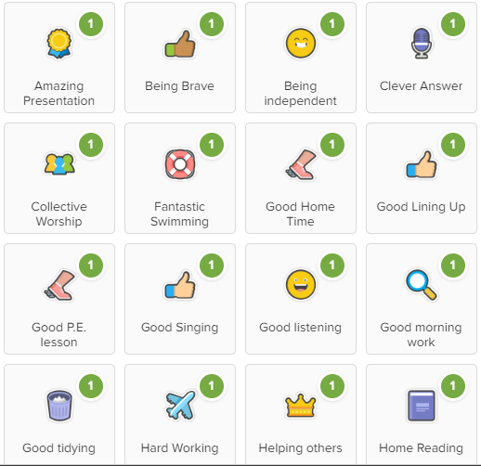
Class Dojo
Members of staff reinforce positive praise by awarding ‘Dojo points’ using the online system ‘Class Dojo’. Points are awarded to children for displaying positive behaviour.

One point is awarded at any given time to ensure consistency across school. The only exception to this, is when a Living the Vision Dojo is awarded – which are worth 3 Dojo points throughout school.

Children ‘collect’ their Dojo points and these are recorded online with the child’s avatar.

The children can then trade in their Dojo points for small prizes at the end of every half-term.

7.2 Whole Class Rewards
Teachers can reward their class if they have achieved an agreed target of shared Dojo points, for example an extra playtime.

7.3 Sanctions
Our prime educational function cannot operate without high levels of pupil engagement. Therefore, we expect all children to listen carefully to instructions, work diligently and respect the work, learning and play of other children. When this is not the case, we apply consequences. The school has created clear guidelines for acceptable behaviour based on promoting, recognising and rewarding consistently positive behaviour.

For some children who have difficulty adopting acceptable behaviour it may be appropriate to focus on and try to correct only one problem at a time. In some cases, a non-verbal signal e.g. a look or frown may be sufficient or a verbal comment may be necessary.

Unacceptable Behaviour
There is no place for violence, bullying, harassment (racial or sexual), vandalism, rudeness to adults or bad language in school and these must be discouraged. Sanctions exist to protect individuals from these negative forms of behaviour. Any incidents of unacceptable behaviour will be logged on CPOMs by either the class teacher / support staff and SLT will be tagged into these incidents so that they are able to monitor behaviour incidents.

Sanctions
Where the code of conduct has been contravened and learning is disrupted, there must be a system of appropriate sanctions. Where possible, sanctions should be seen to match the offence. We must encourage flexibility in the application of sanctions to suit individual children. Minor infringements will be dealt with by the adult responsible for the child at that time.

The school may use one or more of the following sanctions in response to unacceptable behaviour:
 | Possible behaviour | Consequences
Verbal  Warning | - Low level chatting / silliness  - Lack of concentration  - Swinging on furniture  - Shouting out  - Failure to complete class work  - Talking to another student across the classroom  - Distracting others | Verbal warning to be given. State what is happening and remind children of the rules or expectations.
C1 | - Continuation of the above behaviour  - Reluctance to follow instructions after initial warning | Child’s name is recorded in the class consequence book and dated.
C2 | - Continuation of the above behaviours  - Rudeness to another child (not discriminatory) | Loss of 5 minutes of playtime.  This is to be spent with the teacher on duty or class teacher.  Logged in consequence book and dated.
C3 | - Continuation of the above behaviours  - Defiance/showing disrespect to an adult  - Purposeful damage to school property/ equipment (minor)  - Inappropriate physical contact or aggression (not severe)  - Rudeness or inappropriate language which is discriminatory or insulting (towards another child or a member of staff)  - Refusal to work (child to complete missed work during play/lunch until an acceptable amount of work is done) | Loss of 15 minutes of play time (this is to be spent with class teacher or person on duty or member of SLT – any missed work to be completed, a reasonable amount to be done).  Parental contact by class teacher.  Recorded on CPOMS (C3 to be tagged).  At teacher discretion, a child could be sent for a time-out in a different classroom.
C4 | - Continuation of C1-C3 behaviours  - Physical fighting (equally to blame)  - Swearing or inappropriate language which is deliberately racist, sexist, homophobic or discriminatory  - Sexualised language or behaviour (to be decided on by SLT on a case-by-case basis) | Loss of play time and lunch time (to be spent with a member of SLT).  Parental contact by class teacher or SLT if a serious incident.  Recorded on CPOMS (C4 to be tagged).
C5 | - Persistent disruption  - Persistent refusal to follow the school rules  - Aggressive defiance  - Threatening behaviour towards a member of staff  - Damage to school property (serious) | Internal exclusion for half a day/day (may be with a member of SLT or in another class)  Parental contact by a member of SLT  Record logged on CPOMS under internal exclusion (and C5 tagged)
C6 | - Unprovoked physical assault to staff member or child  - Severe and willful damage to school property  - Severe verbal assault  - Extreme refusal to comply  - Persistent disruptive behaviour | SLT decision  Suspension from school  Logged as suspension on CPOMS (with C6 tagged)  Further information can be found in the Trust’s Suspension & Exclusion Policy).
Please note: some pupils with specific needs will be on their own reward/consequence system. This will be decided in conjunction with SLT, Class Teachers, Parents/Carers and the child.

Scripts
When giving a sanction, staff members will follow the following script (where possible, in a private conversation) to ensure clarity and consistency and positively frame behaviour:
“Tom…” (gain attention) “I noticed you called out without raising your hand.” (state behaviour). “Remember, we raise our hand and wait to be chosen before speaking,” (state expectation). (Pause — Sam raises hand). “Thanks, Sam — I’ll come to you next,” (reinforce).
Refusal
Some children in school struggle to manage their behaviour and may refuse at first to do what is asked. Rather than jumping straight in with a Verbal Warning, the below steps need to be used to encourage the child to do what is asked.

Step 1 | Encourage the student in a light-hearted, smiling way: “Hey you can do this. Let’s get you started.”  Don’t make a big deal out of it and escalate the situation. Don’t tell yourself, ‘Here we go again. This child never does any work.’  Don’t get all riled up. Stay upbeat, and don’t show that you’re frustrated or discouraged.  Explain what the child needs to do and then say, “I’m going to come back in 2 minutes and I know that you’ll have made a start.”  Just say, “Alright, great, you’ve written the date. What’s the next step?” and point the student toward getting started.
Step 2 | If that doesn’t work, find out what the problem is in an empathetic way e.g.,  “I notice you’re still not writing. Is this difficult? Can I help?”  Say this quietly, while kneeling down or sitting so you’re at eye level with the student. Give the student a chance to express frustration or anything that’s bothering him or her.  Use phrases such as “I can see that something is upsetting you – let me try and help” or “I am here to help”  With some children, the use of distraction may work (e.g. – asking them to come with you/TA to do a job etc).  DO NOT SAY IN FRONT OF THE CHILD – “he / she is refusing again” or “That’s a Stage 3… for refusing.” (We will still be consistent with consequences but by saying them in this way will just escalate the situation).
Step 3 | If that doesn’t work, explain the natural consequences that will happen e.g., “You need to get started, or you’re going to run out of time. Let’s go.” or “You need this paragraph finished by 10:15”. (Use of a sand timer etc). “What part can I help you with?” or “Are you ready to work on your own?”  You’re not upset or showing frustration at this point, but your tone is very serious. There’s no more smiling now. You’re calm, but you mean business.
Step 4 | If that doesn’t work, let the student experience the consequences and talk to him or her about it.  This is something that’s best done one-on-one, too, i.e. “I have to take break time away for……., which is super disappointing”.  What can we do next time to make sure you’re able to get the work done?”

7.4 Zero-tolerance approach to sexual harassment and sexual violence

The school will ensure that all incidents of sexual harassment and/or violence are met with a suitable response, and never ignored. This includes the sharing of nudes or semi-nudes and up-skirting.

Pupils are encouraged to report anything that makes them uncomfortable, no matter how ‘small’ they feel it might be.

The school’s response will be:
- Proportionate
- Considered
- Supportive
- Decided on a case-by-case basis

Sanctions for sexual harassment and violence may include:
- Contacting parents
- C4 or more serious consequence given (internal isolation or exclusion)

The school has procedures in place to respond to any allegations or concerns regarding a child’s safety or wellbeing. These include clear processes for:
- Responding to a report
- Carrying out risk assessments, where appropriate, to help determine whether to:
- Manage the incident internally
- Use of Brook Traffic Light system to support in decision making
- Refer to Children’s Social Care
- Report to the Police

Please refer to our Child protection and Safeguarding Policy for more information.

7.5 Off-site behaviour
Sanctions may be applied where a pupil has misbehaved off-site when representing the school. This means misbehaviour when the pupil is:

- Taking part in any school-organised or school-related activity (e.g., school trips)
- Travelling to or from school
- Wearing school uniform
- In any other way identifiable as a pupil of our school

Sanctions may also be applied where a pupil has misbehaved off-site at any time, whether or not the conditions above apply, if the misbehaviour:

- Could have repercussions for the orderly running of the school
- Poses a threat to another pupil or member of the public
- Could adversely affect the reputation of the school

Sanctions will only be given out on school premises or elsewhere when the pupil is under the lawful control of the staff member (e.g. on a school-organised trip).

7.6 Malicious allegations
Where a pupil makes an allegation against a member of staff and that allegation is shown to have been deliberately invented or malicious, the school will discipline the pupil in accordance with this policy.

Where a pupil makes an allegation of sexual violence or sexual harassment against another pupil and that allegation is shown to have been deliberately invented or malicious, the school will discipline the pupil in accordance with this policy.

In all cases where an allegation is determined to be unsubstantiated, unfounded, false or malicious, the school (in collaboration with the local authority designated officer, where relevant) will consider whether the pupil who made the allegation is in need of help, or the allegation may have been a cry for help. If so, a referral to Children’s Social Care may be appropriate.

The school will also consider the pastoral needs of staff and pupils accused of misconduct.

Please refer to our Child Protection and Safeguarding Policy for more information on responding to allegations of abuse against staff or other pupils.

8. Behaviour Management

When dealing with poor behaviour choices we are conscious always to maintain a child’s self-esteem and that it is the behaviour that is unacceptable.

We use the staged system (Stage 1 to Stage 6) to ensure that positive classroom behaviour is promoted. At any point, in the case of extreme behaviour that shows no sign of improvement, then a consequence may be escalated. Where there is a persistent disruption, then a personalised home-school monitoring programme may be established. Parents will be involved in this process and school will regularly review progress and impact with parents.

8.1 Recording and reporting the rates and types of behaviour
For each child, teachers record the behaviour and consequence in the class behaviour book (C1-C2) or on CPOMS (C3-C6). These are then analysed by every teacher on a weekly basis with whole school analysis carried out each half-term by SLT. This enables teachers and senior leaders to understand the rates and types of behaviour for individual pupils and classes. This facilitates future actions and any changes to provision and learning. Consequently, as a result of an increase of rate or type of behaviour, some children may require a more personalised approach such as accessing an Individual Behaviour Plan which is communicated and agreed by children, teachers and parents or carers.

8.2 Classroom management
Teaching and support staff are responsible for setting the tone and context for positive behaviour within the classroom.

They will:
- Create and maintain a stimulating environment that encourages pupils to be engaged
- Display our behaviour rules in the classroom
- Develop a positive relationship with pupils, which include:
- Greeting pupils in the morning/at the start of lessons
- Establishing clear behaviour routines
- Communicating expectations of behaviour in ways other than verbally
- Highlighting and promoting good behaviour (rewards/assemblies)
- Concluding the day positively and starting the next day afresh
- Having a plan for dealing with low-level disruption
- Using positive reinforcement

8.3 Physical restraint
Section 93 of the Education and Inspections Act 2006 enables school staff to use reasonable force to prevent a pupil from:
- Committing a criminal offence
- Causing personal injury or damage to a property
- Prejudicing the maintenance of good order and discipline at the school or among the pupils, whether during a teaching session or otherwise.

The DfE document, ‘Use of reasonable force in schools’ offers clarification on the use of force in schools.

In some circumstances, staff may use reasonable force to restrain a pupil to prevent them:

- Causing disorder
- Hurting themselves or others
- Damaging property

Incidents of physical restraint must:

- Always be used as a last resort
- Be applied using the minimum amount of force and for the minimum amount of time possible
- Be used in a way that maintains the safety and dignity of all concerned
- Never be used as a form of punishment
- Be recorded on a significant incident reporting form and uploaded to CPOMS
- Will be reported to parents in writing on the day of the incident

Further information can be found in the Restrictive Interventions Policy (September 2026).

8.4 Confiscation

Any prohibited items (listed in section 3) found in pupils’ possession will be confiscated. These items will not be returned to pupils.

We will also confiscate any item which is harmful or detrimental to school discipline. These items will be returned to pupils after discussion with senior leaders and parents, if appropriate.

Searching and screening pupils is conducted in line with the DfE’s latest guidance on searching, screening and confiscation.

Pupil support
The school recognises its legal duty under the Equality Act 2010 to prevent pupils with a protected characteristic from being at a disadvantage. Consequently, our approach to challenging behaviour may be differentiated to cater to the needs of the pupil.

The school’s Special Educational Needs Co-ordinator (SENCo) will evaluate a pupil who exhibits challenging behaviour to determine whether they have any underlying needs that are not currently being met.

Where necessary, support and advice will also be sought from specialist teachers, an educational psychologist, medical practitioners and/or others, to identify or support specific needs.
When acute needs are identified in a pupil, we will liaise with external agencies and plan support programmes for that child. We will work with parents to create the plan and review it on a regular basis.

Safeguarding
The school recognises that changes in behaviour may be an indicator that a pupil is in need of help or protection. We will consider whether a pupil’s misbehaviour may be linked to them suffering, or being likely to suffer, significant harm. Where this may be the case, we will follow our child protection and safeguarding policy.

- Restorative Practice

9.1 Affective Statements:
The most informal Restorative Practice process on the continuum is the use of affective statements which are simply expressions of personal feelings.

Affective statements help clarify boundaries, provide feedback and build empathy. e.g.

- I’m proud of you because…
- I’m pleased with your behaviour because…
- I feel really pleased that you made the right choice when…
- I felt upset when you… because…

9.2 Proactive Circles
Using proactive circles before problems occur will improve the school climate and create and promote durable behaviours that help children become resilient to difficulties.

Circles by their very structure, convey certain important ideas and values without the need for discussion:
- Equality – Literally everyone in the circle has equal seating.
- Safety & Trust – You can see everyone in a circle, so nothing is hidden.
- Responsibility – Everyone has a chance to play a role in the outcome of the circle.
- Facilitation – The circle reminds the leader to facilitate rather than lecture.
- Ownership – Collectively, the participants feel the circle is theirs.
- Connections – These are built as everyone listens to everyone else’s responses.

Regular check in and check out circles (at least weekly) take place in all classes throughout school. This involves children sitting in a circle, where everyone can see each other and everyone feels involved. Clear rules mean that all children have equal opportunity to participate in the circle. Circles can be used for a wide variety of purpose such as talking about feelings, developing relationships, assessing learning, introducing new learning or discussing behavioural issues. Whatever they are used for, they allow everyone to have a voice and develop confidence when expressing emotions or opinions. They are central to developing our school community and relationships within it. The core values are actively referred to during proactive circles.

9.3 Restorative Circles
Aims:
- Actively engage all participants.
- To separate the actions from the actors
- Allow participants to make amends for harm caused
- To produce a lasting resolution to a problem

These questions seek to elicit the story of the actions and events, the thoughts and feelings associated with those actions and events and solutions for making things right rather than assigning blame and seeking justifications for behaviour. The questions create a feedback loop, so that people can hear how their actions have affected others, and encourage them to take responsibility for those actions. They also pave the way for solutions to problems to be found. It may be necessary to think of and ask assertive questions when stock answers are given.

To respond to challenging behaviour
- What happened? What led up to it? Then what happened?
- What were you thinking about at the time?
- What have your thoughts been since?
- Who has been affected by what you did? Do you think anyone else has been affected?
- In what way have they been affected?
- What do you think needs to happen next?

To help those harmed by others actions:
- What happened? What led up to it? Then what happened?
- What were your thoughts at the time?
- What have your thoughts been since?
- How has this affected you and others?
- What has been the hardest thing for you?
- What do you think needs to happen next?

Pupil transition

To ensure a smooth transition to the next year, pupils have transition sessions with their new teacher(s). In addition, staff members hold transition meetings.

To ensure behaviour is continually monitored and the right support is in place, information related to pupil behaviour issues may be transferred to relevant staff at the start of the term or year.

11. Training

Our staff are provided with training on managing behaviour, including proper use of restraint, as part of their induction process.

Behaviour management will also form part of continuing professional development.

12. Monitoring arrangements
This behaviour policy will be reviewed by the Headteacher and the Governing Board annually. At each review, the policy will be approved by the Headteacher.

13. Links with other policies
This Behaviour Policy is linked to the following policies:

- Exclusion Policy
- Child Protection and Safeguarding Policy
- The Anti-Bullying Policy
- Restrictive Interventions Policy

Appendix 1: Written statement of behaviour principles

- Every pupil understands they have the right to feel safe, valued and respected, and learn free from the disruption of others
- All pupils, staff and visitors are free from any form of discrimination
- Staff and volunteers set an excellent example to pupils at all times
- Rewards, sanctions and reasonable force are used consistently by staff, in line with the Behaviour Policy
- The Behaviour Policy is understood by pupils and staff
- The Exclusions Policy explains that exclusions will only be used as a last resort, and outlines the processes involved in permanent and fixed-term exclusions
- Pupils are helped to take responsibility for their actions
- Families are involved in behaviour incidents to foster good relationships between the school and pupils’ home life

The Governing Board also emphasises that violence or threatening behaviour will not be tolerated in any circumstances

