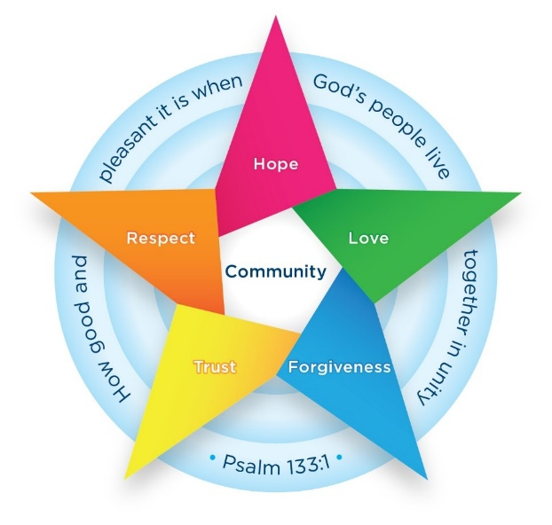

The Batley Parish Way
Behaviour Routines Curriculum

‘Be Brilliant at Batley Parish’
September 2026

 | Autumn 1 | Autumn 2 | Spring 1 | Spring 2 | Summer 1 | Summer 2
Teaching | Explicit teaching  of the full  Batley Parish Way curriculum | Ongoing revision  of content | Longer recap of  Batley Parish Way curriculum | Ongoing revision  of content | Longer recap of  Batley Parish Way curriculum | Ongoing revision of  content
Our Vision
Be Brilliant at Batley Parish!
Together, we are one.
Each of us is a unique thread, and when woven together, we create the strong, colourful fabric of our school community.
Our strengths and differences make us stronger.
Every thread matters.
Together, we are weaving bright futures where anything is possible.

Values
At Batley Parish we develop children’s behaviour and character through the Batley Parish Way behaviour curriculum. In order to build character, we define the behaviours and habits that we expect students to demonstrate. We also know that good learning behaviours help children to learn in a calm, orderly environment. We also focus on one core value each half-term:
Autumn 1 | Autumn 2 | Spring 1 | Spring 2 | Summer 1 | Summer 2
Community | Hope | Love | Forgiveness | Respect | Trust

Teaching the curriculum
The curriculum is taught explicitly during the first week in Autumn term. At the start of each term, the Batley Parish Way behaviour curriculum is revisited with pupils and will continue to be reinforced throughout the year. All adults reinforce these expectations consistently.

1. Identify the routines you want to see
2. Communicate in detail your expectations
3. Practise the routines until everyone can do them
4. Reinforce, maintain and patrol the routines constantly

It is important that all school staff know the details of this curriculum, teach it explicitly to children and continuously maintain the high standards we set.
By doing so we support each other to create a culture where pupils feel safe and are able to learn in an optimised environment and where teachers are free to teach unimpeded.

Adaptations
While this curriculum is for all pupils it will be applied differently in different year groups depending on pupils’ ages and may be applied differently depending on individual pupils’ SEND needs. Sensitivity must be applied at all times when teaching the curriculum.

EYFS
As children in EYFS are still learning about their own personal boundaries, the difference between right and wrong and their ability to understand consequences, the application of the routines in the following policy will slightly differ. The staff and children within the EYFS and will aim towards as many of the routines and expectations they can in line with child development expectations for the child’s age. Therefore, the adaptation of the consequences will occur and will not fall in line with that of main school. We will however still take a strict stance on physical violence/abuse outside the normal development of the child.

Brilliant Walking

I know that we walk around school using Brilliant Walking.

I know that Brilliant Walking means:
- I know I face forwards with my shirt tucked in
- I know that my hands will be at my sides (not in pockets) and that I must not touch anything on walls/displays
- I know that my hood will be down (if wearing a PE hoody)
- I know I walk at a steady pace
- I know that I do not talk
- I know that I should walk in a straight line and single file
- I know that when my teacher puts their hand up then I stop and look and am silent

I know the 1,2,3 signal routine for moving around the classroom
- Hold up one finger: children stand
- Hold up two fingers: children walk and stand behind their chairs / to the line
- Hold up three fingers: children sit down and prepare to read or write / children start to walk silently

I know that we use Brilliant Walking to keep everyone safe in school and to make sure the learning of other children is not disrupted as people move around school.

Role of the adult
- Lead the children out at set times
- High expectations - insist on brilliant walking at all times
- Positive praise and recognition of brilliant walking
- Consistently use the 1-2-3 routine for moving around the classroom

Brilliant Listening

I know that we use Brilliant Listening in class and around school.

- I know that we use magnet eyes - my teacher points to their eyes with two fingers which means my eyes should be on the teacher and my body is still
- I know that I face the listener with nothing in my hands
- I know that I should sit up straight
- I know that I should never interrupt
- I know that I should track the speaker
- I know that I should sit on my chair properly, with my feet on the floor and all the chair legs on the floor (feet to floor, tummy to table, back-to-back)

Team Stop
- I know that when an adult raises their hand, I stop what I am doing, and raise my hand silently (fully raised)
- I know that if someone next to me has not done this then I tap them gently on the arm to get their attention
- I know that I should have empty hands

I know that we do this so that we can hear instructions and can learn.

I know that we all do Brilliant Listening to ensure everybody is able to learn without distractions.

I know that pupils who do not follow school rules will have a consequence for this.

Role of the adult
- High expectations – ensure that everyone is listening before speaking
- Reinforcing what brilliant listening looks like
- Team stop – ensure that everyone raises their hand and stops what they are doing
- Positive praise for children doing this correctly and consistently

Brilliant Manners

- I know that you should always say ‘please’ when you are asking for something
- I know that you should always say ‘thank you’ when you receive something or someone does something nice for you
- I know that you should let any waiting adults through a doorway before walking through yourself
- I know that I should let adults through doors in front of me (this may mean pausing the line to let adults through)
- I know that you should say ‘good morning/afternoon’ to adults if spoken to
- I know that it is polite to give eye contact to the person you are talking to.
- I know that it is important to show gratitude to others by thanking people for what they have done for you.

I know that we do this so that we can hear instructions and can learn.

I know that we all do Brilliant Listening to ensure everybody is able to learn without distractions.

Role of the adult
- Model polite manners to all other adults and children
- Remind children of expectations
- Positive praise
- Speak to all children and staff respectfully

Brilliant Presentation

- I know that I must set my work out neatly in my books and take care over my presentation
- I know that each piece of work needs a date and learning objective (in scrapbook for PSHE)
- I know that you must use ‘one square, one digit’ when writing in maths books
- I know how to underline date and titles using a ruler and a pencil
- I know how to correct mistakes by drawing a straight line through my work
- I know that I must not deface my book
- I know that I must help to keep tables and shared areas tidy
- I know that I must present myself smartly in the correct uniform (no jumpers around waist etc)

I know that we do this because we take pride in our work and want to be the best we can be.

Role of the adult
- Model how to set out work neatly (share examples for children to see)
- Have high expectations
- Remind children when needed to ensure they are trying to ensure their best presentation
- Ensure classrooms and shared spaces are well organised and free of mess/clutter

Other routines

Classroom routines
- I know the order that you always line up in (alphabetical order unless specific child moved for a purpose).
- I know who you stand in front of and who is behind you.
- I know that you should line up without leaning against the walls while moving around school.
- I know that when you come into class on a morning you join in with the first morning task straight away.
- I know that you do not move out of your seat during lessons unless an adult has said to do so.
- I know that I have water in my water bottle for classroom use
- I know that adults may ask monitors to carry out jobs to minimise disruption/talk

Collective worship routines
- I know that adults and children must be silent in worship
- I know that all adults will be in worship on a Monday and Friday
- I know that I must sit cross legged, facing forwards, with my hands in my own space
- I know that I must try to participate in worships whenever possible
- I know that adults will bring us into, and lead us out, of the hall

Playtime routines
- I know that I go outside straightaway at playtime and after I have bought my snack.
- I know that you must walk from your classroom to the playground using Brilliant Walking.
- I know that you must play safely without hurting anyone.
- I know that we do not ‘play fight’ because we may hurt someone by accident.
- I know that you must be kind, by including people in your games and sharing equipment.
- I know that someone who is kind behaves in a gentle, caring, and helpful way towards other people.
- I know that, when told to line up, I must line up in our lining up order quickly.
- I know that when an adult does the ‘Team Stop’ sign then I am silent and look at the grown up.
- I know that I put equipment down straight away when I see the Team Stop.
- I know that my class teacher will greet our class in the playground at the end of break.
- I know that I should eat my snack outside near the classroom door/bin (and not be walking around whilst eating).

Lunchtime routines
- I know that I go outside as soon as I have eaten my lunch (once an adult has told us to leave the hall).
- I know that, when told to line up, I must line up in our lining up order quickly.
- I know that when an adult does the ‘Team Stop’ sign then I am silent and look at the grown up.
- I know that I put equipment down straight away when I see the Team Stop.
- I know that you should always try to use a knife and fork correctly (this will be explicitly taught in EYFS and KS1).
- I know that you should finish what you are eating before leaving your seat and take your plate and cutlery back.
- I know how to use good manners during lunchtime, particularly when receiving food from the school kitchen & talking to Lunchtime Supervisors.
- I know that the Lunchtime Supervisors will do the ‘Team Stop’ sign and I will go out to play when my class is called.
- I know that my class teacher will greet our class in the playground at the end of lunchtime.

School uniform
I know that school uniform consists of:
- Black or grey trousers, skirts or dresses (of an appropriate length);
- Plain black shoes, ankle boots or trainers;
- White or pale blue polo shirts (these must be tucked in);
- Navy blue jumper or cardigan;
Summer alternatives:
- Checked blue and white summer dresses;
- Tailored grey or black shorts.
In PE lessons I should have a simple PE kit consisting of:
- Blue or black shorts with blue or grey leggings (shorts to be of an appropriate length);
- Plain white T-shirt;
- Trainers or plimsolls.

During colder weather, I can wear a track suit over my PE kit for outdoor PE.

Additional items:
- Some children choose to wear clothing items of religious significance, such as head scarves. These must be navy blue or grey, in line with the rest of our uniform.
- Children who wish to wear tights or leggings should wear navy blue or grey items.
- There is no requirement to wear branded items at Batley Parish. School jumpers with the school logo are available but are not compulsory. Our uniform is designed to be affordable and parents are free to shop around to find the best value items for their children, as long as they are within the colour expectations listed above.
- Hair accessories should be simple and in school colours.

Jewellery
I know that, on health and safety grounds, we do not allow pupils to wear jewellery in school except for a wrist watch (smart watches are not permitted).
A single pair of stud earrings may be worn on days that are not PE days.

Attendance and punctuality
- I know that attending school on time every day is important so that you do not miss important learning.
- I know that you must try to attend school every day.
- I know that you must try to arrive at school on time every day.

Behaviour outside of school
- I know that when you are wearing your school uniform you are representing the school community and must always behave responsibly and respectfully.
- I know that I need to be careful when online and I need to make sure that I am kind, respectful and safe whilst doing so.
- I know that you should be considerate of other people arriving and leaving school.
- I know that being considerate means thinking about other people’s needs, wishes and feelings.
- I know that examples of being considerate on the way home include walking not running, giving people plenty of space, using a quiet voice not shouting.
- I know that the Batley Parish Way behaviour curriculum must be followed at all times.
- I know that all pupils follow the Batley Parish Way behaviour curriculum to become better learners and to build positive habits which will help everyone to be successful throughout life.

